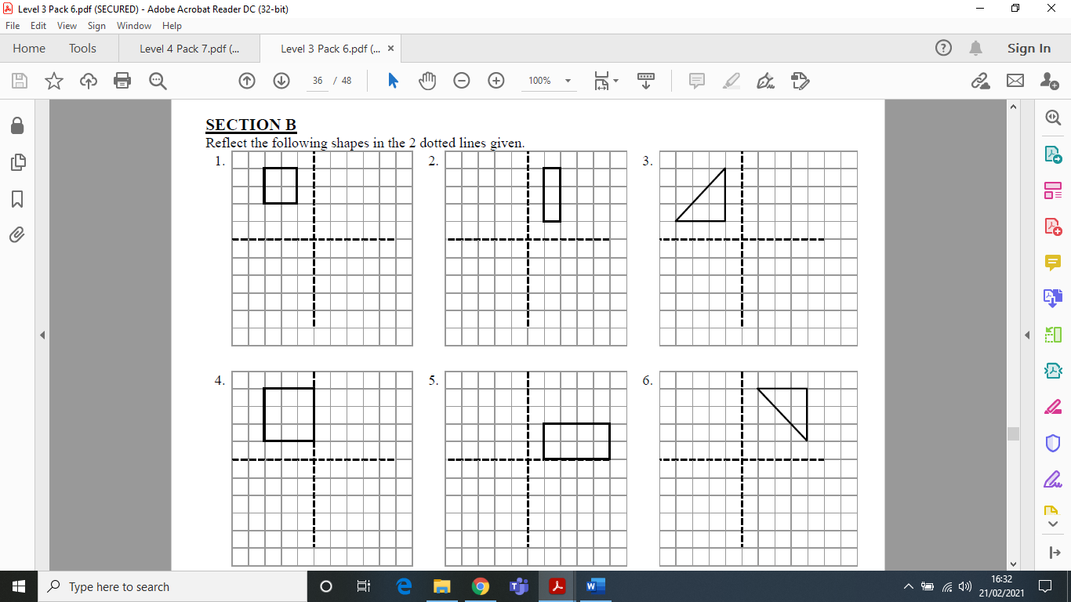
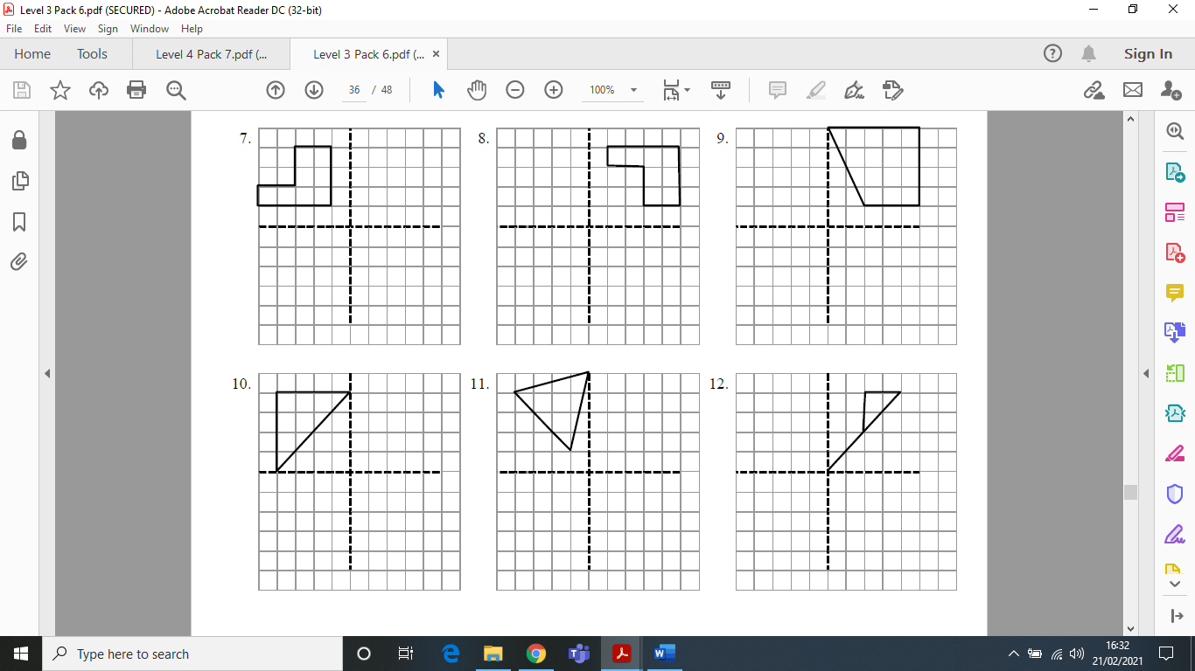
Reflection 2
Reflect the following shapes across the x and y axis (dotted lines).

