Willow Class Home Learning Term 5
Shackleton’s Journey
 | Activity
 | History  Research other famous explorers in history (eg. Christopher Columbus, Scott and Amundsen, Neil Armstrong). Write about their achievements and any struggles they had along the way. Include dates, maps, pictures etc. | 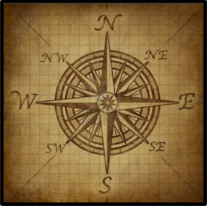
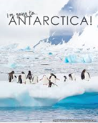 | Antarctic Explorers Spotters Guide  Research animals that Shackleton may have encountered on this expedition and present them in the form of a non-chronological report. Remember to include details, pictures and any interesting facts.
 | Science  The amount of daylight varies around the world as well as at different times of the year. Research how the Earth’s rotation and tilt explains day and night in the Antarctic and the climate in this area of the world.  Write an explanation using diagrams and pictures to help you explain. | 
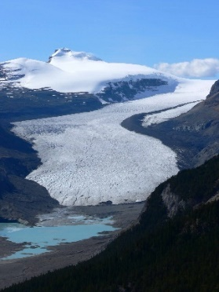 | Geography  Research glaciers, what they are, where are they, how they move, what geographical features they create, etc.  Create a non-chronological report to explain all about them. Don’t forget to use picture, maps, diagrams to help you explain.
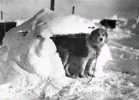 | A Dog’s Life!  Use your imagination to write a diary in the role of one of the dogs on the expedition. Write about your experiences on board the ship and how your life changed when the Endurance became trapped in the ice. Remember to include details, feelings and emotions and any humorous incidents that happened along the way.  The following YouTube clip may help with some ideas for this – search ‘Shackleton’s Imperial Trans Antarctic Expedition 1914’ It should be the first one on the list (approx 21:30 mins long). | 

