Year 5 – How can following God bring freedom and justice?

Introduction
The unit for this term is based on the Christian concept of People of God.
The concept People of God is the story of God’s people in the Old Testament.

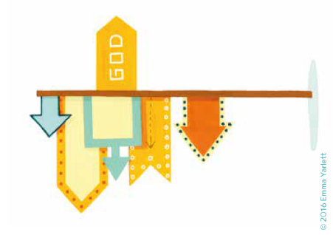
Look carefully at the icon card for the Christian concept People of God.
- What do you notice?
- What do you think it represents?
- How does it help you understanding of People of God?

Look carefully at the Big Frieze panel representing People of God

- What do you notice?
Annotate the frieze panel with your thoughts and questions about it.
- Which Old Testament Bible stories can you spot?
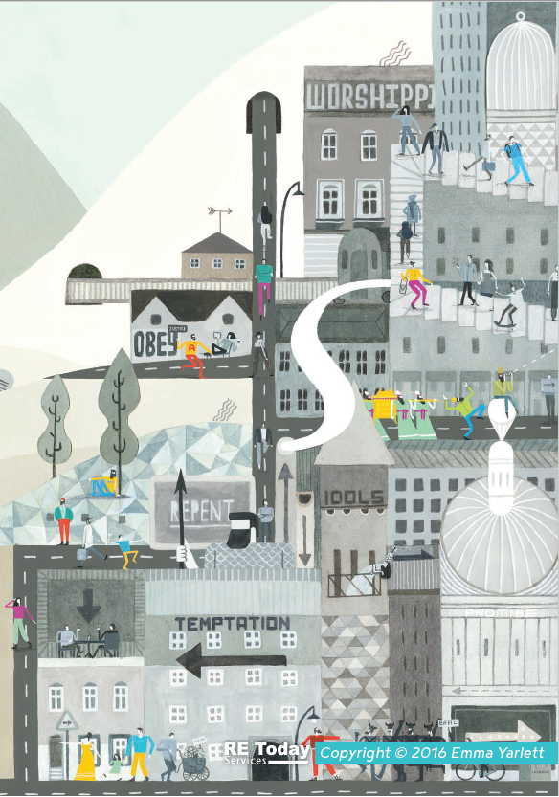
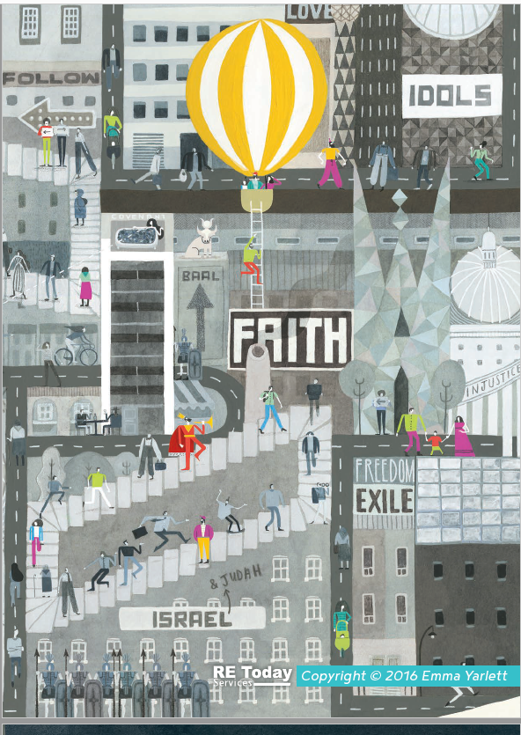


Think about the big question for this term: How can following God bring freedom and justice?
- Write a few words or phrases that come to mind when you read this question.

- What questions do you have about the big question for this term? What do you think you will need to find out to answer it?

How can following God bring freedom and justice?

Write the words ‘freedom’ and ‘justice’ on different sheets of paper. Look at the definition from the dictionary below and then write as many associated ideas around them as you can – other similar words, famous people that these words remind you of, action words associated with these key words.

Freedom | Justice
The condition or right of being able or allowed to do, say, think, etc. whatever you want to, without being controlled or limited.  People are trying to bring freedom to refugees living in Syria. | Fairness in the way people are dealt with or treated.  Black Lives Matters protestors are seeking justice for those who have been treated unfairly.

- Why might people seek for freedom or fight for justice in our world today?

- Why might Christians seek for freedom and fight for justice in our world today?

