SESSION 2: How does the story of Moses from the book of Exodus help our thinking about freedom and justice?


What do you know about the story of Moses from the Old Testament?
Look carefully at this image and think about what you can remember. What do you notice? Use the words below to help you talk about this image.
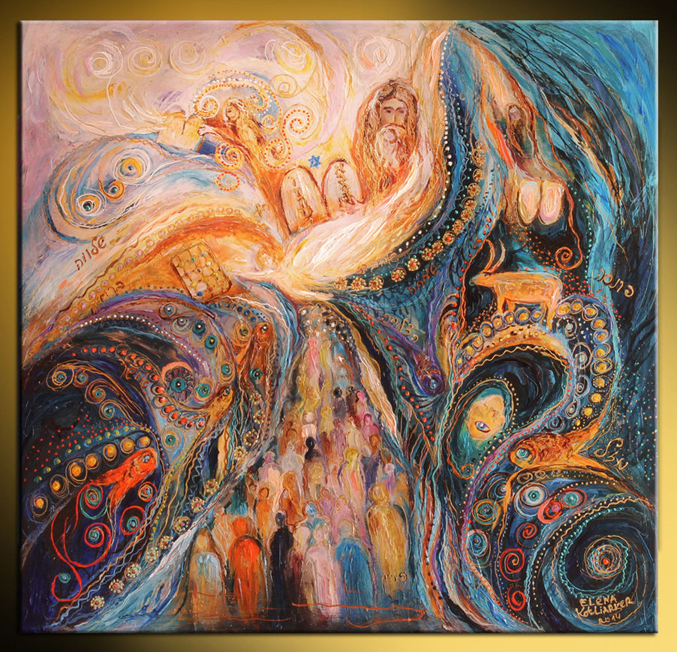

10 commandments | Prince of Egypt | Moses basket | Burning bush
10 plagues | Freed the Israelite slaves | Hebrew family | plagues


Using Bible Gateway https://www.biblegateway.com/ look up each of these Bible passages that tell the life of Moses. (Click on the hyperlink)

Read each part of the story of Moses.
Summarise and write or draw that part of the story in each box.
Exodus 2:1-10 | Exodus 2: 11-15 | Exodus 3:1 to Exodus 4:17

https://www.bibleinfo.com/en/questions/what-are-10-plagues-egypt (video summary of Exodus 7-12)

Exodus 12:33-42 | Exodus 15:1-20


Watch this video clip to help you visualise the story of Moses. Bible Quest: Moses « RE:start (request.org.uk)


- How did God, through Moses, bring freedom and justice to God’s people?

- What difference do you think freedom and justice had on the lives of the Israelites?

Think back through the story of Moses. Where can you spot these key themes in his story?
freedom | god | suffering | Leadership
vulnerability | obedience | evil | greed

Thinking about all you have learned, read and thought about in this lesson, answer this question:
- How does the story of Moses from the book of Exodus help your thinking about freedom and justice?

- Thinking about the story of Moses, how did following God bring them freedom and justice?

