SESSION 1: Why did God’s people need freedom and justice?

God’s people, the Israelites (they were also called Hebrews) were living in Egypt as many of them had moved to live there when a famine hit Israel under the rule of Joseph. The Israelites grew strong and prospered in Egypt.

Read this Bible passage to find out what happened next to the Israelites.
Exodus 1: 8- 14
⁸ Then a new king began to rule Egypt, who did not know who Joseph was. ⁹ This king said to his people, “Look! The people of Israel are too many and too strong for us to handle! ¹⁰ If we don’t make plans against them, the number of their people will grow even more. Then if there is a war, they might join our enemies and fight us and escape from the country!”
¹¹ So the Egyptians made life hard for the Israelites. They put slave masters over them, who forced the Israelites to build the cities Pithom and Rameses as supply centres for the king. ¹² But the harder the Egyptians forced the Israelites to work, the more the Israelites grew in number and spread out. So, the Egyptians became very afraid of them ¹³ and demanded even more of them. ¹⁴ They made their lives bitter. They forced the Israelites to work hard to make bricks and mortar and to do all kinds of work in the fields. The Egyptians were not merciful to them in all their painful work.
²² So the king commanded all his people, “Every time a boy is born to the Hebrews, you must throw him into the Nile River, but let all the girl babies live.”


- Why did the Israelites become slaves? Was it their fault?
- What must it have been like to be a slave in Egypt?

- What things do you think they could not do as slaves?

This is a painting was found in Ancient Egypt. It shows the Israelite slaves working with the Egyptian slave owners watching over them.
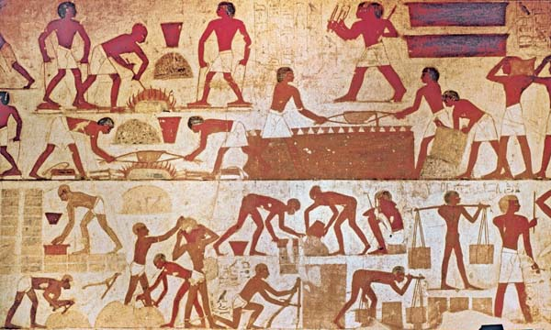


Annotate the image with some thoughts and feelings of the Israelite slaves.

Thinking about all you have learned and read in this session, answer this question as fully as you can.
- Why did God’s people need freedom and justice?

