
Ollie - SESSION 3: Why did God give his people the 10 commandments?
After the Israelites left Egypt, they wandered around in the wilderness desert, waiting to go into the land God had promised them.
God spoke to Moses at the top of Mount Sinai in the wilderness and gave him the 10 commandments. The commandments were a set of rules to guide God’s people in the best way to live.

Read the Bible passage below, where God sets out the 10 commandments.

Highlight which of these rules are about God and which of them are about other people in two different colours.
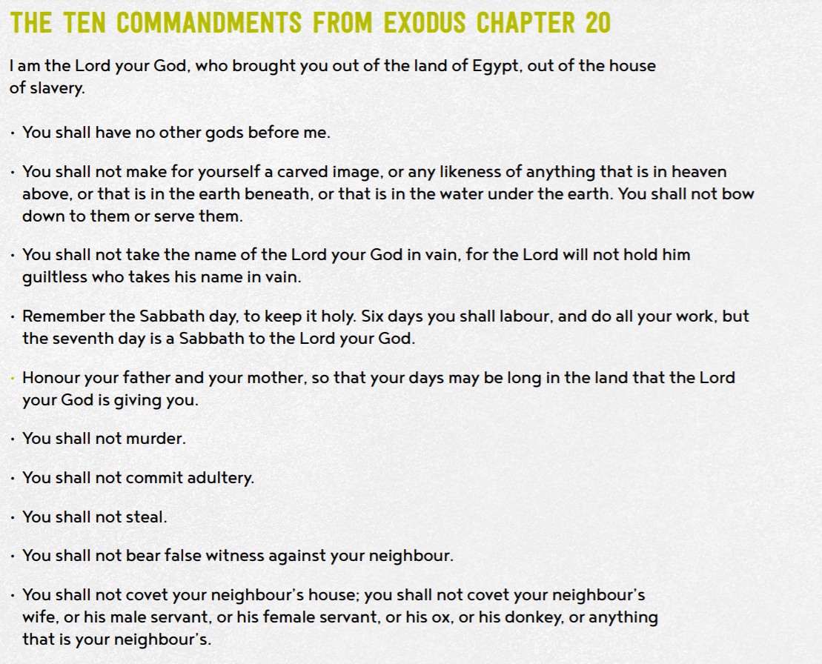

About God
About God

About God

About God
About People

About People
About People
About People
About People
About People


- Why do you think God gave his people these rules?
How must God’s people have been behaving to need these rules?

I think God gave these rules to make sure that everyone lived fairly and treated everyone the same. God’s people must have been behaving badly. They must have done everything that is in the rules for God to make them and to stop anyone from doing them in the future. The rules also teaches people to respect their parents and be kind to everyone.
- Why do you think these rules might have been important for God’s people?
To make sure that they knew right from wrong and what God expected of them. They must have needed help and shown how to behave towards each other.

- What might have happened if God had not have given his people the 10 commandments?
I think if God had not given the 10 commandments, his people would just live how they want to. They would steal and commit murder and they could commit adultery. They could break all of the rules and then there would be chaos. You wouldn’t be able to tell right from wrong or do anything about it.


Give 3 good reasons why Christian and Jewish people think the 10 commandments are still important today.

Make sure there are Because it is still Because committing
consequences for people wrong to steal from some adultery is still wrong
commit murder one else

Give 3 reasons why an atheist (a person who does not believe in the existence of God) might think the 10 commandments are not important today.
I think someone who an atheist might not agree not being allowed to have a
Doesn’t believe in God with being told to save the carved image of God isn’t
Would think that ‘to have 7th day of the week to worship important because nothing
No other God than me’ isn’t God happens to you if you did
Fair or important anyway


- Do you think they are still important today?
Tell me more about your response and opinion.
I think most of the commandments are important today are numbers 5 – 10 because they teach you to be fair and kind to people and their things. You should know right from wrong and have respect for your parents.
I don’t think that 1 – 4 are that important for me and what I do in my life but I know that they are important to other people like Christians and Jews.
- Which of the Commandments do you think would be hardest for a Christian to keep? Explain your choice.

- Which Commandments would have most impact on the world, if everyone followed them.

I think the commandments that would have most impact in the world if everyone followed them would be 5-10

Thinking about all you have learned, read and thought about today answer this question:
- Why did God give his people the 10 commandments?
To keep everyone sharing and caring for each other and to know what is right and wrong. To teach us about being kind and fair and respect others.

