
SESSION 3: Why did God give his people the 10 commandments?
After the Israelites left Egypt, they wandered around in the wilderness desert, waiting to go into the land God had promised them.
God spoke to Moses at the top of Mount Sinai in the wilderness and gave him the 10 commandments. The commandments were a set of rules to guide God’s people in the best way to live.

Read the Bible passage below, where God sets out the 10 commandments.

Highlight which of these rules are about God and which of them are about other people in two different colours.
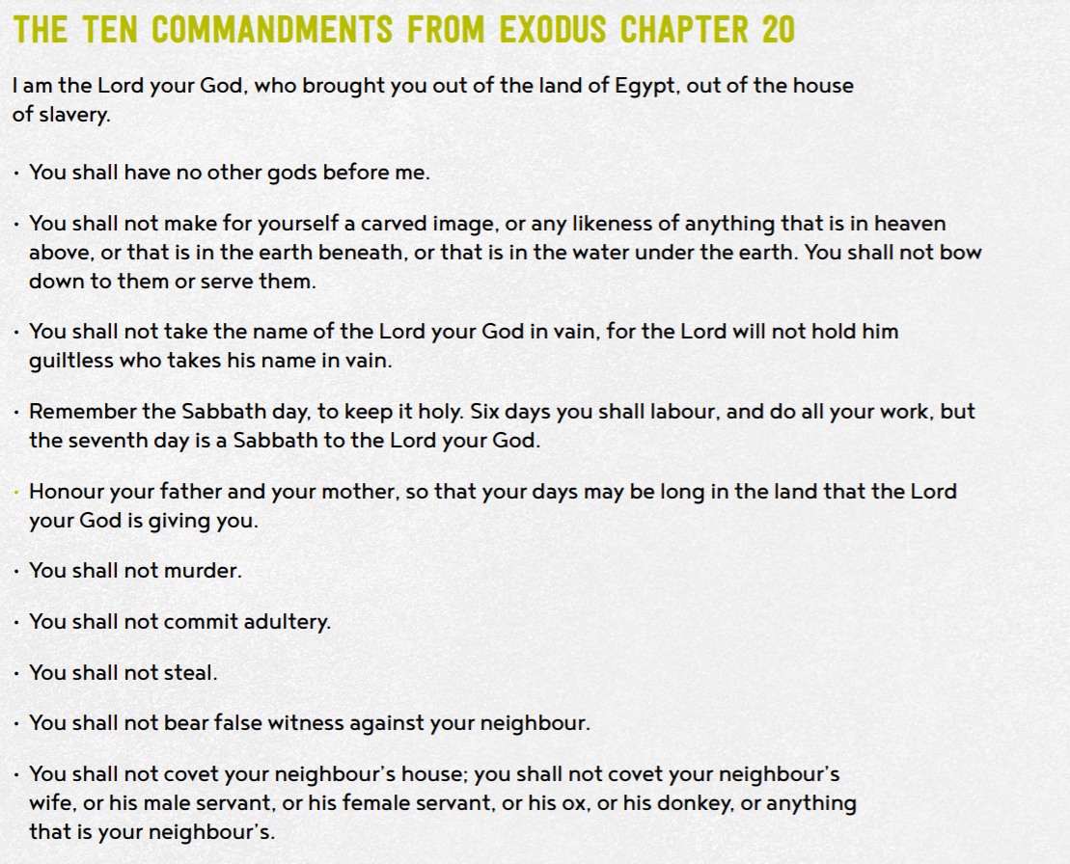


- Why do you think God gave his people these rules?

I think God made these rules for his people, because this is how he wanted people to behave and they are good rules to live by.

How must God’s people have been behaving to need these rules?

People must have been behaving how they shouldn’t and maybe it was a carnage.

- Why do you think these rules might have been important for God’s people?

The rules are important because they resemble things you shouldn’t do and it shows them how to protect people and teach their children how to behave.

- What might have happened if God had not have given his people the 10 commandments?
People would be treating others badly and it would not be a nice world to be a part of.


Give 3 good reasons why Christian and Jewish people think the 10 commandments are still important today.

Good examples of good behavior
Teaches people how to behave.
Makes the world a nice place.
Give 3 reasons why an atheist (a person who does not believe in the existence of God) might think the 10 commandments are not important today.

They do not believe so why follow them
They are outdated and old
For christens to follow not them


- Do you think they are still important today?
Tell me more about your response and opinion.

I believe some are important than others. The not murdering, stealing, adultery and lying are important

- Which of the Commandments do you think would be hardest for a Christian to keep? Explain your choice.

The hardest would be to rest on the sabbath day, because now people work all different hours and can’t choose to have that day off.

- Which Commandments would have most impact on the world, if everyone followed them.

Not to murder would have the biggest impact. It would stop sadness and pain for the losing the person and also less prisons.

