
SESSION 3: Why did God give his people the 10 commandments?
After the Israelites left Egypt, they wandered around in the wilderness desert, waiting to go into the land God had promised them.
God spoke to Moses at the top of Mount Sinai in the wilderness and gave him the 10 commandments. The commandments were a set of rules to guide God’s people in the best way to live.

Read the Bible passage below, where God sets out the 10 commandments.
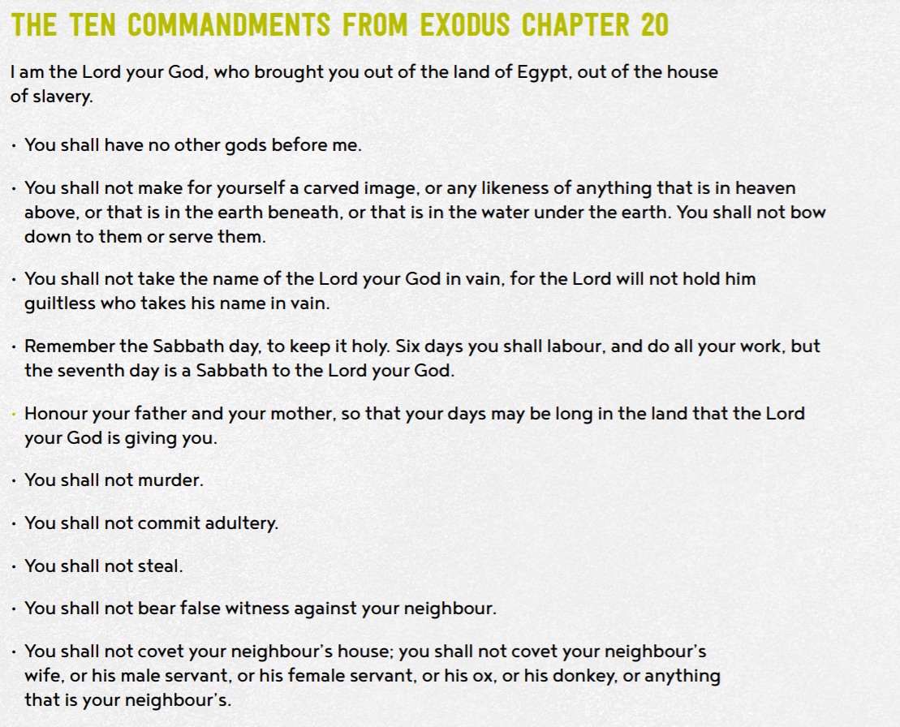

Highlight which of these rules are about God and which of them are about other people in two different colours.


- Why do you think God gave his people these rules?
How must God’s people have been behaving to need these rules?
They must have been very naughty for god to have written those rules. He made them to help the people live in peace and harmony.

- Why do you think these rules might have been important for God’s people?
They were important because they needed to obey god in everything they did as God had saved them from slavery and they trusted him.

- What might have happened if God had not have given his people the 10 commandments?

Give 3 good reasons why Christian and Jewish people think the 10 commandments are still important today.
You can’t change your past but you can change your future.
In the past we were one religion and we still need to follow the most important rules.
Although humans have evolved the most important rules stay the same.

Give 3 reasons why an atheist (a person who does not believe in the existence of God) might think the 10 commandments are not important today.
They don’t know how good a leader god is.
They don’t believe in god.
They don’t believe that god wrote the commandments.


- Do you think they are still important today?
Tell me more about your response and opinion.
Yes, because they are the rules that god made and god is a leader and lord so we should respect him in everything that he does for us.
- Which of the Commandments do you think would be hardest for a Christian to keep? Explain your choice.
The commandment about Sabbath day as some Christians have to work on a Sunday e.g Doctors, Nurses and shopkeepers.

- Which Commandments would have most impact on the world, if everyone followed them.
All of them because god made them to make the world a better place.

Thinking about all you have learned, read and thought about today answer this question:
- Why did God give his people the 10 commandments? So that they could live a life of peace instead of a horrible life as a slave.

