
SESSION 3: Why did God give his people the 10 commandments?
After the Israelites left Egypt, they wandered around in the wilderness desert, waiting to go into the land God had promised them.
God spoke to Moses at the top of Mount Sinai in the wilderness and gave him the 10 commandments. The commandments were a set of rules to guide God’s people in the best way to live.

Read the Bible passage below, where God sets out the 10 commandments.

Highlight which of these rules are about God and which of them are about other people in two different colors.
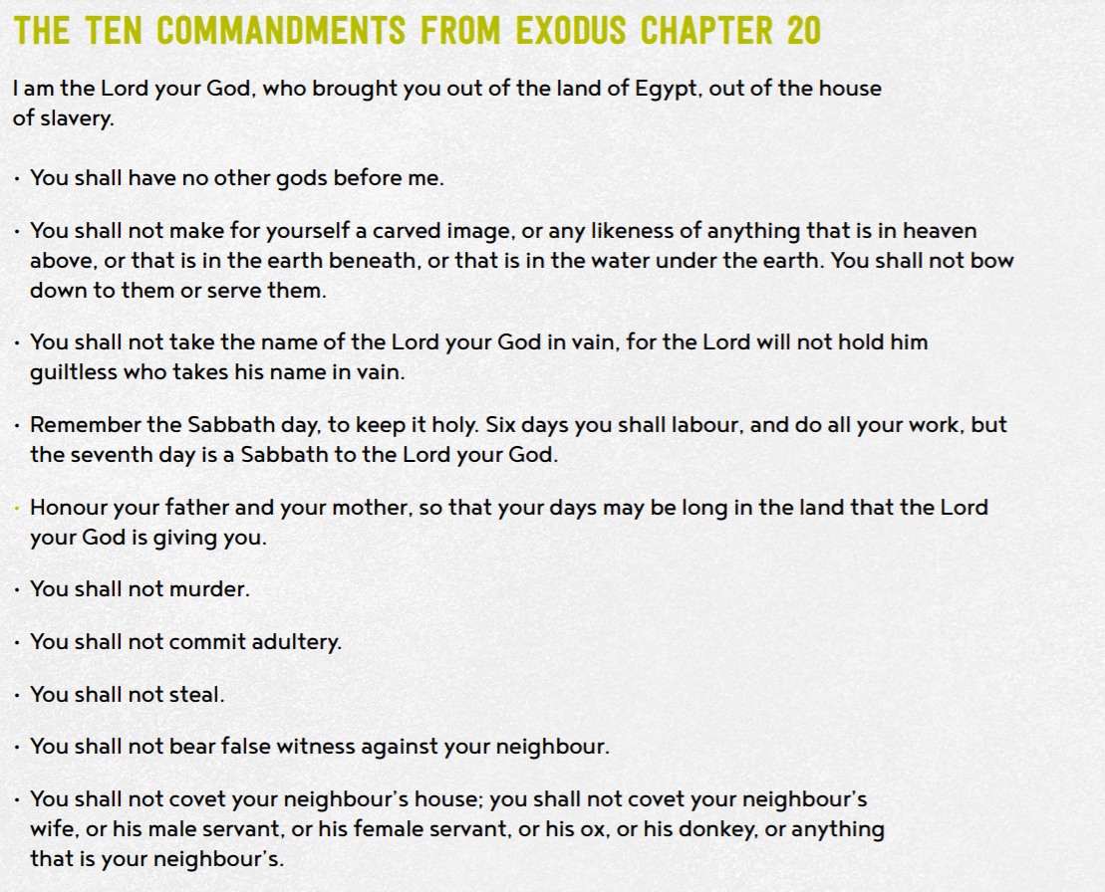


- Why do you think God gave his people these rules?
- God gave his people these rules because he wants the best for them, and to keep them safe.

How must God’s people have been behaving to need these rules?
Gods people must have been behaving the opposite to how god wanted them to, to need these rules.

- Why do you think these rules might have been important for God’s people?
- These rules might have been important to Gods people because without them they would not have lived the way God wanted them to God just want the best for them.

- What might have happened if God had not have given his people the 10 commandments?

If God had not gave the 10 commandments, then no one would love God their would-be problems all over the world.

Give 3 good reasons why Christian and Jewish people think the 10 commandments are still important today.
God made the world and knew what is best for his people.

If we did not have rules the whole world would be a mess.

Without rules there would be no such thing as discipline.

Give 3 reasons why an atheist (a person who does not believe in the existence of God) might think the 10 commandments are not important today.
They do not believe in God so they don’t need to follow what he commands.

They can follow the government rules instead.

They believe that they can work out what to do them selves.


- Do you think they are still important today?
Tell me more about your response and opinion.

I think that the 10 commandments are important today because rules are needed to help humans to live together peacefully.

- Which of the Commandments do you think would be hardest for a Christian to keep? Explain your choice.
- I think it depends on the person which commandment they would find difficult to keep.

- Which Commandments would have most impact on the world if everyone followed them? The first commandment would have most impact on the world if everyone followed it because if you worshipped only God, then you would follow all the other commandments.

Thinking about all you have learned, read, and thought about today answer this question:
- Why did God give his people the 10 commandments?
- God gave his people the 10 commandments because he wanted them to live happily together and be in relationship with God.

