SESSION 2: How does the story of Moses from the book of Exodus help our thinking about freedom and justice?


What do you know about the story of Moses from the Old Testament?
Look carefully at this image and think about what you can remember. What do you notice? Use the words below to help you talk about this image.
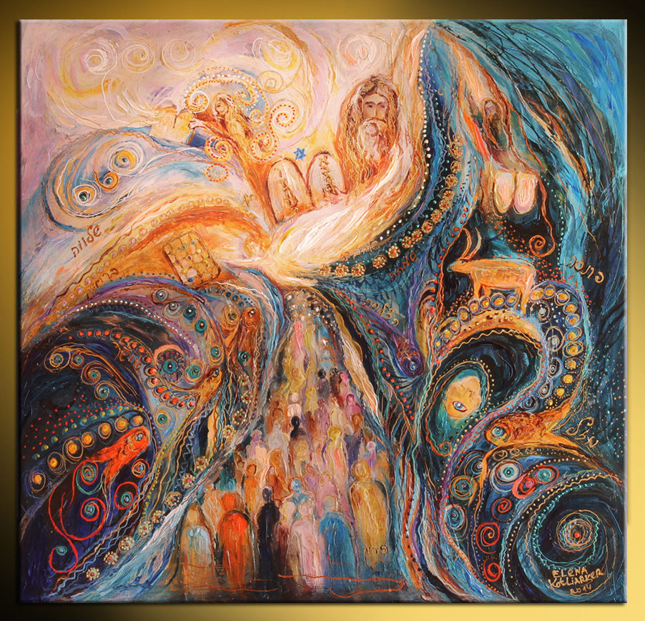

10 commandments | Prince of Egypt | Moses basket | Burning bush
10 plagues | Freed the Israelite slaves | Hebrew family | plagues


Using Bible Gateway https://www.biblegateway.com/ look up each of these Bible passages that tell the life of Moses. (Click on the hyperlink)

Read each part of the story of Moses.
Summarise and write or draw that part of the story in each box.
Exodus 2:1-10 | Exodus 2: 11-15 | Exodus 3:1 to Exodus 4:17
A Hebrew lady got pregnant and raised her baby for 3 months secretly, then put him in the Nile. The king’s daughter adopted the baby and called him Moses. | Moses sees an Egyptian fighting a Hebrew so he kills the Egyptian and buries him in the sand. People find the body and try to kill Moses but Moses runs away to a nearby well. | Moses is in the desert leading a flock of sheep and he sees a burning bush so he goes closer even though the bush is burning, it is still green. He hears the voice of God and he tells him to go and free the Israelites from the Egyptians.

https://www.bibleinfo.com/en/questions/what-are-10-plagues-egypt (video summary of Exodus 7-12)

- Water turns to blood
- Plague of frogs
- Plague of lice
- Plague of flies
- Plague of livestock
- Plague of boil
- Plague of hail
- Plague of locust
- Plague of darkness
- Death of firstborn baby

Exodus 12:33-42 | Exodus 15:1-20
Moses goes to Egypt and rescues the Israelites and they all bring rich gifts and food from the Egyptians. | Moses and his people sing a song to praise the lord.


Watch this video clip to help you visualise the story of Moses. Bible Quest: Moses « RE:start (request.org.uk)


- How did God, through Moses, bring freedom and justice to God’s people?
God told Moses to rescues the people of Israel from the Egyptians.

- What difference do you think freedom and justice had on the lives of the Israelites?
It made their lives better because they could do what they want when they want do it

Think back through the story of Moses. Where can you spot these key themes in his story?
freedom | god | suffering | Leadership
vulnerability | obedience | evil | greed

Thinking about all you have learned, read and thought about in this lesson, answer this question:
- How does the story of Moses from the book of Exodus help your thinking about freedom and justice? That freedom and justice is all about not being bossed around and that it is actually all about having fun.

- Thinking about the story of Moses, how did following God bring them freedom and justice? Moses did what God told him to do and he succeeded in doing what God told him to do.

