SESSION 2: How does the story of Moses from the book of Exodus help our thinking about freedom and justice?
People need freedom and justice because they then will not be able to live the life they want to live.


What do you know about the story of Moses from the Old Testament?
God gave him a power to set everyone free from slavery and go far away. So Moses parted the sea and did exactly what he said he would do.
Look carefully at this image and think about what you can remember. What do you notice?
Moses parting the sea to lead every one to safety.
Use the words below to help you talk about this image.
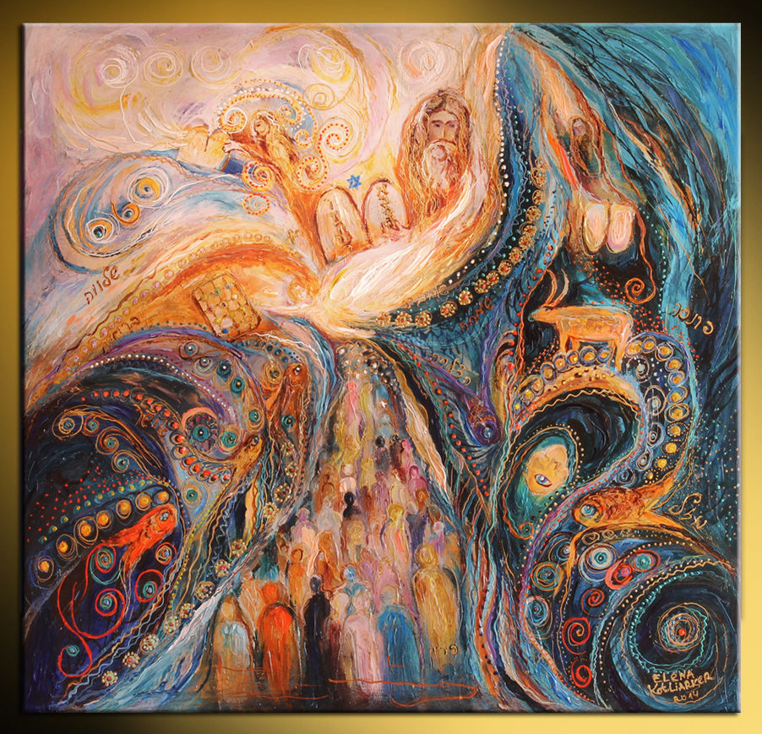

10 commandments | Prince of Egypt | Moses basket | Burning bush
10 plagues | Freed the Israelite slaves | Hebrew family | plagues


Using Bible Gateway https://www.biblegateway.com/ look up each of these Bible passages that tell the life of Moses. (Click on the hyperlink)

Read each part of the story of Moses.
Summarise and write or draw that part of the story in each box.
Exodus 2:1-10 | Exodus 2: 11-15 | Exodus 3:1 to Exodus 4:17
The king’s daughter said to the woman, ”Take this baby and nurse him for me, and I will pay you.” So the woman took her baby and nursed him. When the child grew older, the woman took him to the king’s daughter, and adopted the baby as her own son. The king’s daughter named him Moses, because she had pulled him out of the water. | Moses grew and became a man. One day he visited his people and saw that they were forced to work very hard. He saw an Egyptian beating a Hebrew man, one of Moses’ own people. Moses looked all around and saw that no one was watching, so he killed the Egyptian and hid his body in the sand | The elders will listen to you. And then you and the elders of Israel will go to the king of Egypt and tell him, ‘the lord, the god of the Hebrews, appeared to us. Let us travel three days into the dessert, across oceans and over lands to offer sacrifices to the Lord our god.

https://www.bibleinfo.com/en/questions/what-are-10-plagues-egypt (video summary of Exodus 7-12)

Unfortunately pharaoh didn’t let the Hebrews go free and Egypt suffered extreme devastation because of the 10 plagues. There was not much left in Egypt after the plagues and the parting of the Red Sea.

Exodus 12:33-42 | Exodus 15:1-20
The people of Israel had lived in Egypt for four hundred thirty year ^{on} the very day the four hundred thirty years ended, the Lord’s divisions of people left Egypt. That night the Lord kept watch to bring them out of Egypt, and so on this same night the Israelites are to keep watch to honour the Lord from now on. | Moses and the Israelites sang a song to the lord.  The horses, chariot drivers, and chariots of the king of Egypt went into the sea, and the Lord covered them with water from the sea. But the Israelites walked through the sea on dry land. ²⁰ Then Aaron’s sister Miriam, a prophetess, took a tambourine in her hand. All the women followed her, playing tambourines and dancing.


Watch this video clip to help you visualise the story of Moses. Bible Quest: Moses « RE:start (request.org.uk)


- How did God, through Moses, bring freedom and justice to God’s people?
God wanted to set the Israelites free and he parted the river so they could get to the other side. They were then safe.

- What difference do you think freedom and justice had on the lives of the Israelites?
Having freedom and justice meant the Israelites could live a happier and more normal life instead of being slaves.

Think back through the story of Moses. Where can you spot these key themes in his story?
freedom | god | suffering | Leadership
vulnerability | obedience | evil | greed

Thinking about all you have learned, read and thought about in this lesson, answer this question:
- How does the story of Moses from the book of Exodus help your thinking about freedom and justice?
I think having freedom and justice is very important because if you don’t have freedom then you can’t live your life how you want to.

