SESSION 1: Why did God’s people need freedom and justice?

- Why did the Israelites become slaves? Because the Egyptian’s were scared of them.
- Was it their fault? No
- What must it have been like to be a slave in Egypt? Horrible.
- What things do you think they could not do as slaves? Travel.

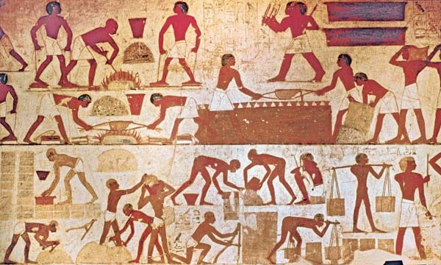


Annotate the image with some thoughts and feelings of the Israelite slaves.


Thinking about all you have learned and read in this session, answer this question as fully as you can.
- Why did God’s people need freedom and justice?
To live their lives properly which they could not do because of the EVIL EGYPTIONS!

