SESSION 1: Why did God’s people need freedom and justice?


- Why did the Israelites become slaves? Was it their fault? – because there were too many of them and they were strong. The king said that if they don’t do something about it, the people of Israel could grow and could join enemies to fight against them. It wasn’t the Israelites fault that they became slaves.

- What must it have been like to be a slave in Egypt? – it must have been really horrible to be a slave because the Egyptians made them work really hard and it is hot in Egypt. The Egyptians were still frightened of the Israelites because they still grew in number so the Egyptians made them work even harder. And they killed the baby boys to stop them growing into strong men.

- What things do you think they could not do as slaves? – I think the slaves didn’t have any freedom so they couldn’t just go to toilet when they wanted or eat and drink. They were probably chained up or had people watching over them so they couldn’t escape. I don’t think that the slaves could see their families or go back to their home.

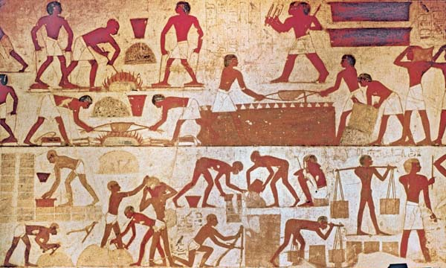


Annotate the image with some thoughts and feelings of the Israelite slaves. In the painting I can see that the Israelite slaves are bent over and working hard lifting and carrying heavy things and being watched all the time by the Egyptian slave owners that didn’t do anything to help them.

Thinking about all you have learned and read in this session, answer this question as fully as you can.
- Why did God’s people need freedom and justice?
The Israelites needed freedom and justice because they worked hard, and they had already left Israel to escape Joseph’s rule that had caused famine. They didn’t deserve to be slaves or have their baby boys killed in the River Nile. They built the cities Pithom and Rameses, so they should’ve have then deserved their freedom.

