SESSION 5: How can following God bring freedom and justice?

Following Biblical teaching and the example of Jesus, many Christians around the world seek to bring freedom and justice for everyone.
They do this in many ways; for example, supporting charities who bring resources or education to communities, sponsor children or farming projects, praying with others for situations of injustice, raising money and awareness and supporting fair trade projects.

Isaiah 1: 17
Learn to do right; seek justice.
Defend the oppressed.
Take up the cause of the fatherless;
plead the case of the widow.


- What do you think this Bible verses teaches Christians about how they should act towards others?

Extreme poverty, famine, disease, and failed harvest can result in people feeling trapped or ‘enslaved’ because there seems to be no way out, freedom or hope for the future.
All these examples show how Christians are trying to bring people out of ‘slavery’ and into freedom and hope.

Many people fight for justice for those who are vulnerable, so they can have the same opportunities and resources as people living in other parts of the world.

- Why do you think Christians around the world are fighting for freedom and justice for people?



What’s Fairtrade?
Fairtrade is about better prices, decent working conditions, local sustainability, and fair terms of trade for farmers and workers in the developing world.
By requiring companies to pay sustainable prices (which must never fall lower than the market price), Fairtrade tackles the injustices of conventional trade, which traditionally discriminates against the most vulnerable. It enables them to improve their position and have more control over their lives.
With Fairtrade you have the power to change the world every day. With simple shopping choices you can get farmers a better deal. And that means they can make their own decisions, control their future and lead the dignified life everyone deserves.

- Why do you think many Christians choose to buy Fairtrade products?


Look carefully at this image. By imagining that the world is made up of 100 people, it helps to clearly see the differences in how people live.
What do you notice?
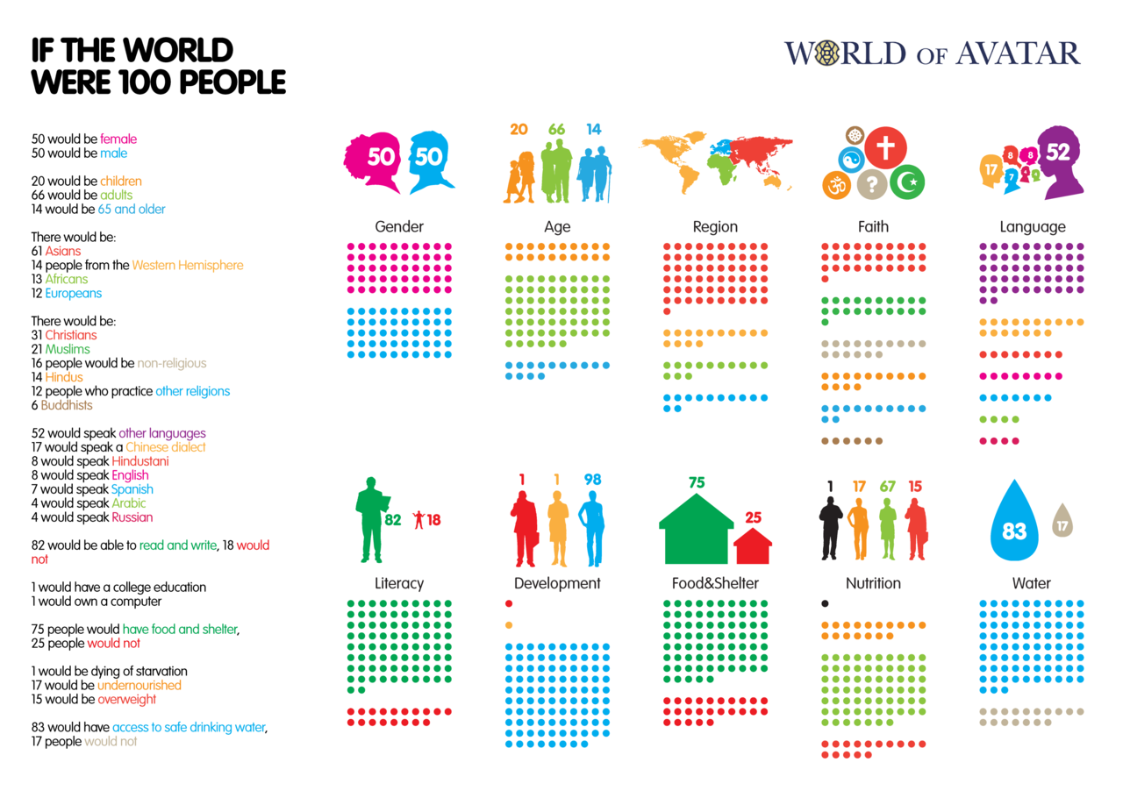


How does it make you feel when you see these figures?

Is it fair that 25 people do not have access to food and shelter?
Is it fair that 17 people do not have access to clean drinking water?
Is it fair that 17 people do not have enough to eat so are undernourished and 1 person would die of starvation?
- What response might a Christian give to these figures?

If you had to write 10 lessons for living to encourage everyone to bring more freedom and justice to others – what would they be?

RULES FOR LIVING
1
2
3
4
5
6
7
8
9
10


Tell me more about why you chose these rules for living.

Thinking about everything you have learned in this unit answer these questions:
- How does following God bring freedom and justice?

- Can people who do not follow God bring freedom and justice?

Tell me more about your answer

