
SESSION 4: How do Christians apply the ideas of freedom and justice to their ways of living in the world today?
In the New Testament Jesus set out his teaching on how God wanted his followers to behave and act. These were called the new commandments as they encompassed the 10 commandments from the Old Testament into two simple verses.


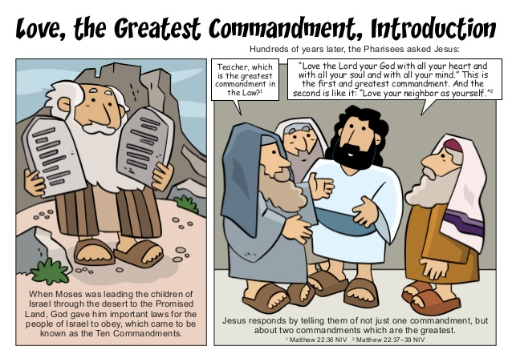
Read this Bible passage from the book of Matthew in the New Testament
Matthew 22:37-40, International Children’s Bible
³⁷ Jesus said, ‘Love the Lord your God with all your heart, soul and mind.’ ³⁸ This is the first and most important command. ³⁹ And the second command is like the first: ‘Love your neighbour as you love yourself.’ ⁴⁰ All the law and the writings of the prophets depend on these two commands.”

- What are the two rules about?

- How do they encompass the 10 commandments given to Moses?


Here are some scenarios to think about. Read and think about each one.

- How might a Christian respond to these if they follow the two commandments Jesus set out?
- How might they end differently if the two commandments were not followed?
Draw or write your responses.

Following the two commandments | Scenario | NOT following the two commandments
 | Someone never lets you join in
 | Someone is in your group for groupwork but behaves badly or messes about
 | Someone who you have never met before but who needs your help e.g. a homeless person
 | When you see a situation of injustice on the news or in your community.
 | When someone is making fun of what you believe

There are many Christian charities who seek to bring freedom and fight for justice for people all around the world.

- Why do you think Christian charities do this work?

Read Orbisa’s story – she lives in Ethiopia with her 2 children.
As you read this story, think about how freedom and justice would help this family.

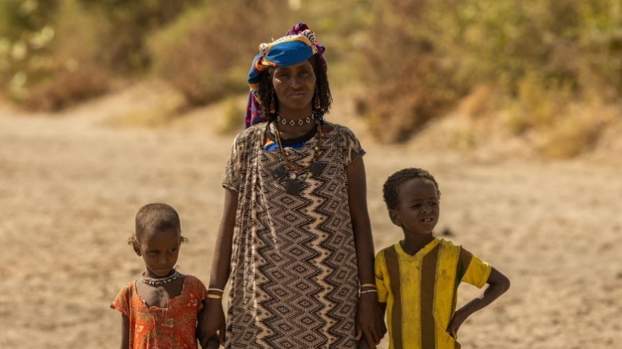

‘Life is very challenging here; we have no food and are dependent on our livestock for our livelihood. Whenever there is no rainfall, our animals die as there is no grass or water. This affects our lives significantly. We will not get money or have milk to drink. We have no other option,’ says Orbisa.
During the rainy season, Orbisa could collect water from a river just five minutes’ walk from her village. As the dry season has extended due to the changing climate, this river has now dried up and no longer provides for Orbisa and her family. ‘The water I collect is not sufficient, I am only able to collect less than half of what my family needs each day’, she says. Now, Orbisa has to walk for up to ten hours every day to collect water for her family. Due to the searing heat, Orbisa is forced to start walking before sunrise, often leaving her village at 4am. The walk is very dangerous as she faces wild animals, including hyenas and leopards.
‘The water I collect is not sufficient, I am only able to collect less than half of what my family needs each day. We need most of it for drinking, but sometimes it is not enough, and my family has to go to bed thirsty. I feel extremely sad whenever I cannot provide water for my children,’ says Orbisa.

Tearfund, is a Christian organisation committed to help Orbisa and other people in similar situations.
Tearfund is changing lives, by working with local partners, like Friendship Support Association (FSA), to set up solar-powered wells that will provide clean water closer to communities. This will help to restore hope and give new life for all who live there. Tearfund’s mission is to follow Jesus where the need is greatest, responding to crisis and partnering with local churches to bring restoration to those living in poverty.

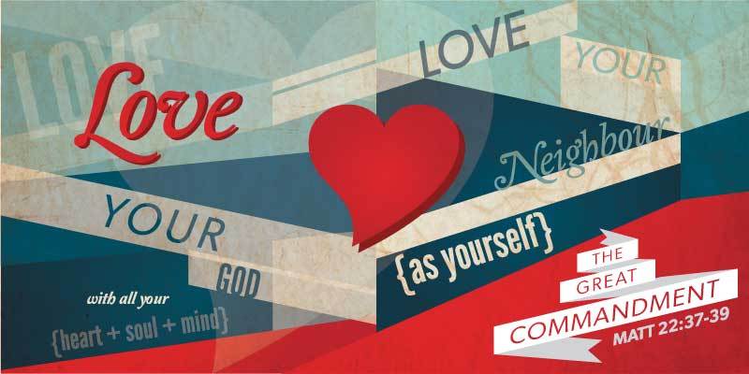


- How is Tearfund living out Jesus’ two commandments for Orbisa?

- How is Tearfund bringing freedom and justice to Orbisa?

Thinking about all you have read, thought about and learned in this lesson, answer this question:
- How do Christians apply the ideas of freedom and justice to their ways of living in the world today?

