
SESSION 3: Why did God give his people the 10 commandments?
After the Israelites left Egypt, they wandered around in the wilderness desert, waiting to go into the land God had promised them.
God spoke to Moses at the top of Mount Sinai in the wilderness and gave him the 10 commandments. The commandments were a set of rules to guide God’s people in the best way to live.

Read the Bible passage below, where God sets out the 10 commandments.

Highlight which of these rules are about God and which of them are about other people in two different colours.
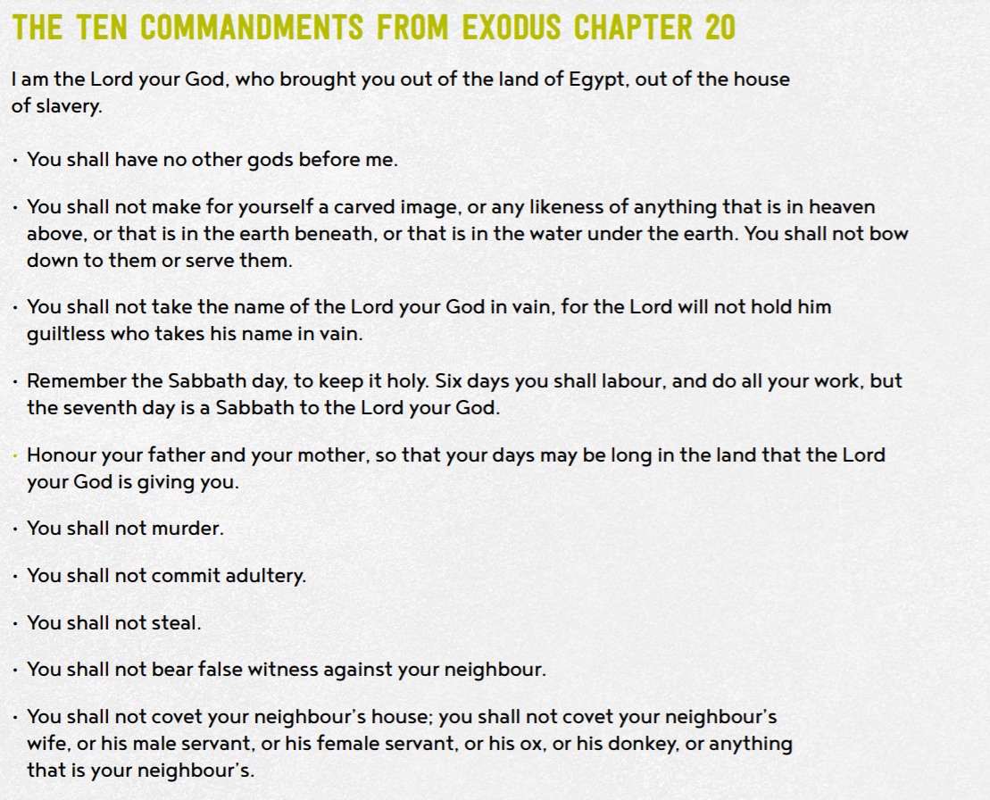


- Why do you think God gave his people these rules?
How must God’s people have been behaving to need these rules?

- Why do you think these rules might have been important for God’s people?

- What might have happened if God had not have given his people the 10 commandments?

Give 3 good reasons why Christian and Jewish people think the 10 commandments are still important today.

Give 3 reasons why an atheist (a person who does not believe in the existence of God) might think the 10 commandments are not important today.


- Do you think they are still important today?
Tell me more about your response and opinion.

- Which of the Commandments do you think would be hardest for a Christian to keep? Explain your choice.

- Which Commandments would have most impact on the world, if everyone followed them.

Thinking about all you have learned, read and thought about today answer this question:
- Why did God give his people the 10 commandments?

