Ollie Cross

SESSION 5: How can following God bring freedom and justice?

Following Biblical teaching and the example of Jesus, many Christians around the world seek to bring freedom and justice for everyone.
They do this in many ways; for example, supporting charities who bring resources or education to communities, sponsor children or farming projects, praying with others for situations of injustice, raising money and awareness and supporting fair trade projects.

Isaiah 1: 17
Learn to do right; seek justice.
Defend the oppressed.
Take up the cause of the fatherless;
plead the case of the widow.


- What do you think this Bible verses teaches Christians about how they should act towards others? I think this verse teaches us to always look after people and do what is right for them and our world. They have been told to look after the women that have lost their husbands and support them with their children.

Extreme poverty, famine, disease, and failed harvest can result in people feeling trapped or ‘enslaved’ because there seems to be no way out, freedom or hope for the future.
All these examples show how Christians are trying to bring people out of ‘slavery’ and into freedom and hope.

Many people fight for justice for those who are vulnerable, so they can have the same opportunities and resources as people living in other parts of the world.

- Why do you think Christians around the world are fighting for freedom and justice for people? I think the Christians around the world are fighting for freedom and justice so everyone can have the same thing and the same changes in life. They are looking to help people so they can have food and a home like the rest of the world.

What’s Fairtrade?
Fairtrade is about better prices, decent working conditions, local sustainability, and fair terms of trade for farmers and workers in the developing world.
By requiring companies to pay sustainable prices (which must never fall lower than the market price), Fairtrade tackles the injustices of conventional trade, which traditionally discriminates against the most vulnerable. It enables them to improve their position and have more control over their lives.
With Fairtrade you have the power to change the world every day. With simple shopping choices you can get farmers a better deal. And that means they can make their own decisions, control their future and lead the dignified life everyone deserves.

- Why do you think many Christians choose to buy Fairtrade products? I think many Christians would choose to buy Fairtrade things because it then helps give people like farmers more freedom. They can make their own decisions and not be bossed around and controlled by bigger companies that make people pay more money. If more people bought Fairtrade things then it would be fairer for everyone because more people could afford good food without it costing too much for people.


Look carefully at this image. By imagining that the world is made up of 100 people, it helps to clearly see the differences in how people live.
What do you notice?
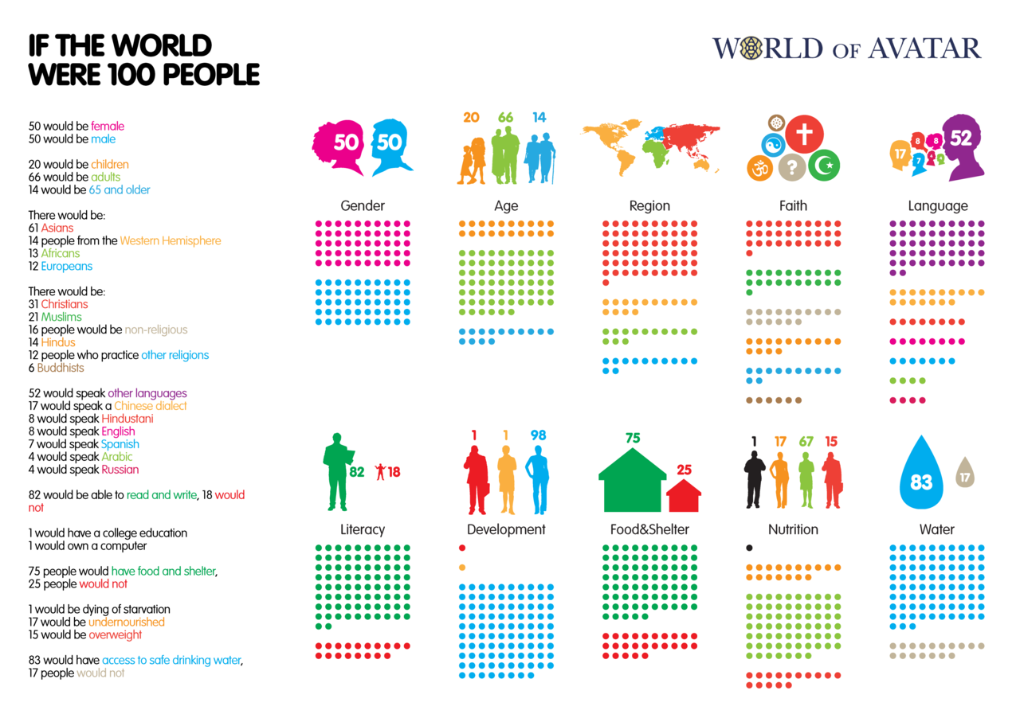


How does it make you feel when you see these figures? – I feel sad when I see these figures because everyone should have the same amount of water and food and choices that lots of us have. It isn’t right that there are some people in the world who are actually dying of starvation when we have lots of food in our house all of the time.

Is it fair that 25 people do not have access to food and shelter? No
Is it fair that 17 people do not have access to clean drinking water? No
Is it fair that 17 people do not have enough to eat so are undernourished and 1 person would die of starvation? No
- What response might a Christian give to these figures? I think a Christian would be very sad about these figures and look at how they could raise money so they could help the people in the world that need a home and food and clean water.

If you had to write 10 lessons for living to encourage everyone to bring more freedom and justice to others – what would they be?

RULES FOR LIVING
1 | Be kind to everyone
2 | Don’t bully anyone or judge them
3 | Eat healthy food and get lots of exercise
4 | Listen more and don’t lose your temper
5 | Help other people and ask how they are feeling
6 | Help support charities that raise money for disadvantaged people and animals
7 | Have respect for other people and don’t be selfish
8 | Make people laugh and feel good about themselves
9 | Be environmentally friendly and look after the planet
10 | Buy from local shops and help the farmers


Tell me more about why you chose these rules for living.
I chose these rules because I think more people to look after other people and nicer. My mum is always saying that if more people were kinder to each other then it would a better world. I think that if everyone did the right thing and not do bad things to other people then they would be happier and not so stressed and worried.

Thinking about everything you have learned in this unit answer these questions:
- How does following God bring freedom and justice?
I think if you follow God and the commandments then you can bring freedom and justice by treating people fairly and making sure that everyone has the same chance to be happy and have nice things so they can look after their family.

- Can people who do not follow God bring freedom and justice?

Tell me more about your answer

I think if you don’t follow God you can still know what is right and wrong and you can still look after people and make sure you are kind and nice to other people.

