SESSION 5: How can following God bring freedom and justice?

Following Biblical teaching and the example of Jesus, many Christians around the world seek to bring freedom and justice for everyone.
They do this in many ways; for example, supporting charities who bring resources or education to communities, sponsor children or farming projects, praying with others for situations of injustice, raising money and awareness and supporting fair trade projects.

Isaiah 1: 17
Learn to do right; seek justice.
Defend the oppressed.
Take up the cause of the fatherless;
plead the case of the widow.


- What do you think this Bible verses teaches Christians about how they should act towards others?
This verse teaches Christians that they need to be kind and caring towards other people in their town.

Extreme poverty, famine, disease, and failed harvest can result in people feeling trapped or ‘enslaved’ because there seems to be no way out, freedom or hope for the future.
All these examples show how Christians are trying to bring people out of ‘slavery’ and into freedom and hope.

Many people fight for justice for those who are vulnerable, so they can have the same opportunities and resources as people living in other parts of the world.

Why do you think Christians around the world are fighting for freedom and justice for people?

Christians around the world are fighting for freedom and justice because they believe that although we are all unique we should all be treated the same, given the same opportunities to help us live a happy and successful life.

What’s Fairtrade?
Fairtrade is about better prices, decent working conditions, local sustainability, and fair terms of trade for farmers and workers in the developing world.
By requiring companies to pay sustainable prices (which must never fall lower than the market price), Fairtrade tackles the injustices of conventional trade, which traditionally discriminates against the most vulnerable. It enables them to improve their position and have more control over their lives.
With Fairtrade you have the power to change the world every day. With simple shopping choices you can get farmers a better deal. And that means they can make their own decisions, control their future and lead the dignified life everyone deserves.

- Why do you think many Christians choose to buy Fairtrade products?
Christians may choose to buy Fairtrade products so that although can’t physically help the people they can help them by buying their products.


Look carefully at this image. By imagining that the world is made up of 100 people, it helps to clearly see the differences in how people live.
What do you notice?
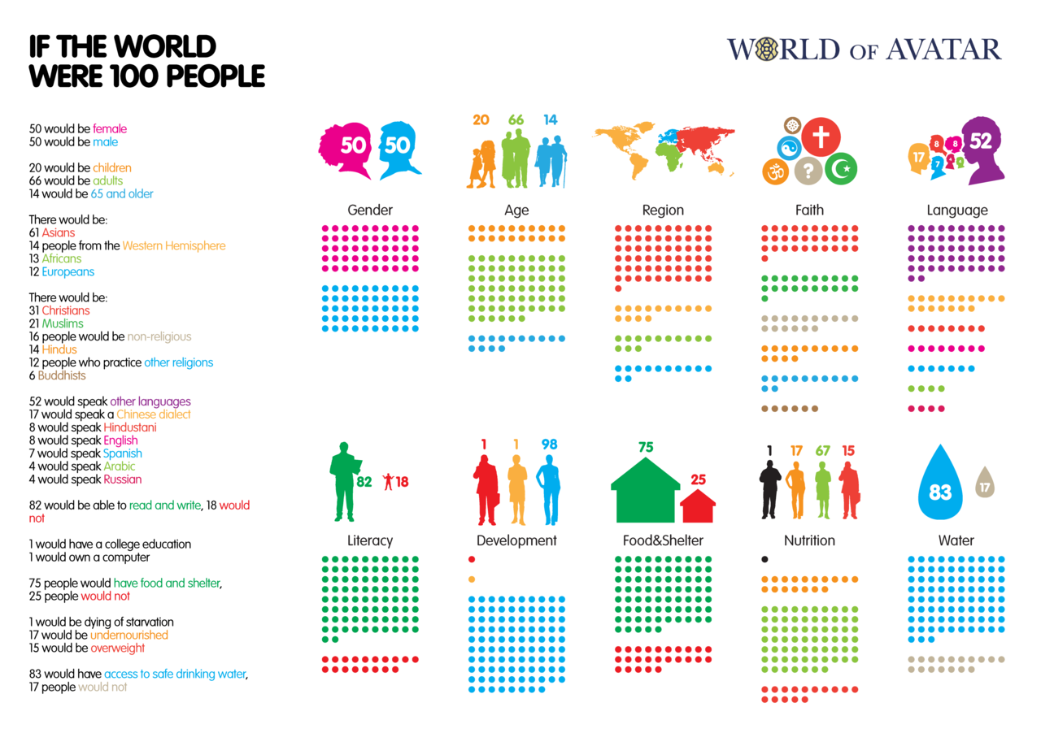


How does it make you feel when you see these figures?
It makes me very sad to see someone dying of starvation and seeing how many people are less fortunate.

Is it fair that 25 people do not have access to food and shelter? NO, everyone should have this.
Is it fair that 17 people do not have access to clean drinking water? NO, everyone should have this.

Is it fair that 17 people do not have enough to eat so are undernourished and 1 person would die of starvation? NO because if there is enough food to make 15 people overweight then surely there should be enough food to go round.
- What response might a Christian give to these figures? God wanted this world to be a world that everyone loves but these figures are just sad because God wanted this world to be a world for everyone and for everyone to be treated the same.

If you had to write 10 lessons for living to encourage everyone to bring more freedom and justice to others – what would they be?

RULES FOR LIVING
1 | Treat people how you want to be treated
2 | Don’t murder
3 | Make this the best world ever
4 | Bring peace to the world
5 | Be kind to people
6 | Respect others
7 | Help the less fortunate
8 | Don’t litter
9 | Make our world a greener world
10 | Take care of the environment.


Tell me more about why you chose these rules for living.
I chose these rules because I know that these are all things that the world needs us to do.

Thinking about everything you have learned in this unit answer these questions:
- How does following God bring freedom and justice?
Following God brings freedom and justice because God built this world for freedom and justice.

- Can people who do not follow God bring freedom and justice?

Tell me more about your answer
Yes they can bring freedom and justice because anyone can bring freedom and justice in their own way.

