
SESSION 4: How do Christians apply the ideas of freedom and justice to their ways of living in the world today?
In the New Testament Jesus set out his teaching on how God wanted his followers to behave and act. These were called the new commandments as they encompassed the 10 commandments from the Old Testament into two simple verses.


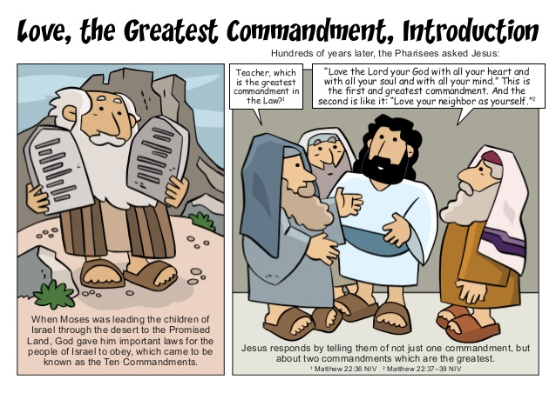
Read this Bible passage from the book of Matthew in the New Testament
Matthew 22:37-40, International Children’s Bible
³⁷ Jesus said, ‘Love the Lord your God with all your heart, soul and mind.’ ³⁸ This is the first and most important command. ³⁹ And the second command is like the first: ‘Love your neighbour as you love yourself.’ ⁴⁰ All the law and the writings of the prophets depend on these two commands.”

- What are the two rules about? You love your god . Treat them how you want to be treated.

- How do they encompass the 10 commandments given to Moses? Yes because they tell people to behave and do good things to others


Here are some scenarios to think about. Read and think about each one.

- How might a Christian respond to these if they follow the two commandments Jesus set out?
- How might they end differently if the two commandments were not followed?
Draw or write your responses.

Following the two commandments | Scenario | NOT following the two commandments
They would let the person join because they are loving and caring because they are kind. | Someone never lets you join in | They would not let the person join in because they don’t follow the two commandments because they are a horrible person.
They would say don’t mess about (in a polite way) , overwise you will get in lots of trouble because they trying to be helpful. | Someone is in your group for groupwork but behaves badly or messes about | They would rudely say stop messing about.
They would help them to get money and food because they like to be nice. | Someone who you have never met before but who needs your help e.g. a homeless person | They wouldn’t help them to get money and food because they care about helping people.
They would help people in the situation because they want people to be safe. | When you see a situation of injustice on the news or in your community. | They wouldn’t help people in a situation because they want people be to get hurt.
They would say that’s not nice and stand up to them but in a polite way. | When someone is making fun of what you believe | They would argue back and get angry.

There are many Christian charities who seek to bring freedom and fight for justice for people all around the world.

- Why do you think Christian charities do this work?

To help people, that need it because everyone should have a chance.

Read Orbisa’s story – she lives in Ethiopia with her 2 children.
As you read this story, think about how freedom and justice would help this family.

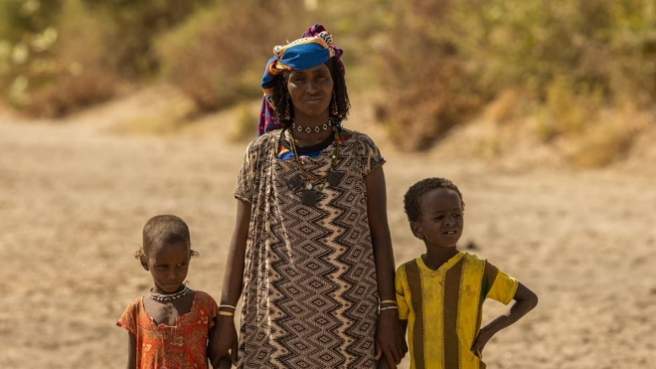

‘Life is very challenging here; we have no food and are dependent on our livestock for our livelihood. Whenever there is no rainfall, our animals die as there is no grass or water. This affects our lives significantly. We will not get money or have milk to drink. We have no other option,’ says Orbisa.
During the rainy season, Orbisa could collect water from a river just five minutes’ walk from her village. As the dry season has extended due to the changing climate, this river has now dried up and no longer provides for Orbisa and her family. ‘The water I collect is not sufficient, I am only able to collect less than half of what my family needs each day’, she says. Now, Orbisa has to walk for up to ten hours every day to collect water for her family. Due to the searing heat, Orbisa is forced to start walking before sunrise, often leaving her village at 4am. The walk is very dangerous as she faces wild animals, including hyenas and leopards.
‘The water I collect is not sufficient, I am only able to collect less than half of what my family needs each day. We need most of it for drinking, but sometimes it is not enough, and my family has to go to bed thirsty. I feel extremely sad whenever I cannot provide water for my children,’ says Orbisa.

Tearfund, is a Christian organisation committed to help Orbisa and other people in similar situations.
Tearfund is changing lives, by working with local partners, like Friendship Support Association (FSA), to set up solar-powered wells that will provide clean water closer to communities. This will help to restore hope and give new life for all who live there. Tearfund’s mission is to follow Jesus where the need is greatest, responding to crisis and partnering with local churches to bring restoration to those living in poverty.




- How is Tearfund living out Jesus’ two commandments for Orbisa?
Tearfund is living out the commandments, by helping Orbis because they want every child to have the right to water.

- How is Tearfund bringing freedom and justice to Orbisa?
I think it is important for her to have freedom and justice, by giving the wells she has clean water, and they don’t go thirsty and have time to work and gain more freedom by earning money. Also, it means she can stay in a safer environment.

Thinking about all you have read, thought about and learned in this lesson, answer this question:
- How do Christians apply the ideas of freedom and justice to their ways of living in the world today?

I think Christians apply the ideas of freedom and justice for poor people because they want everyone the opportunity to be safe in a loving and caring world.

