
Session 4 - Learning question: Why is happiness important to Humanists?
What does happiness mean? (You can’t use the word happy or happiness in your answer!)


How would you describe happiness?

Here are some possible ingredients of happiness.
- Do you agree?
- Would you add anything else?
- Which ones do you think might not make people happy?



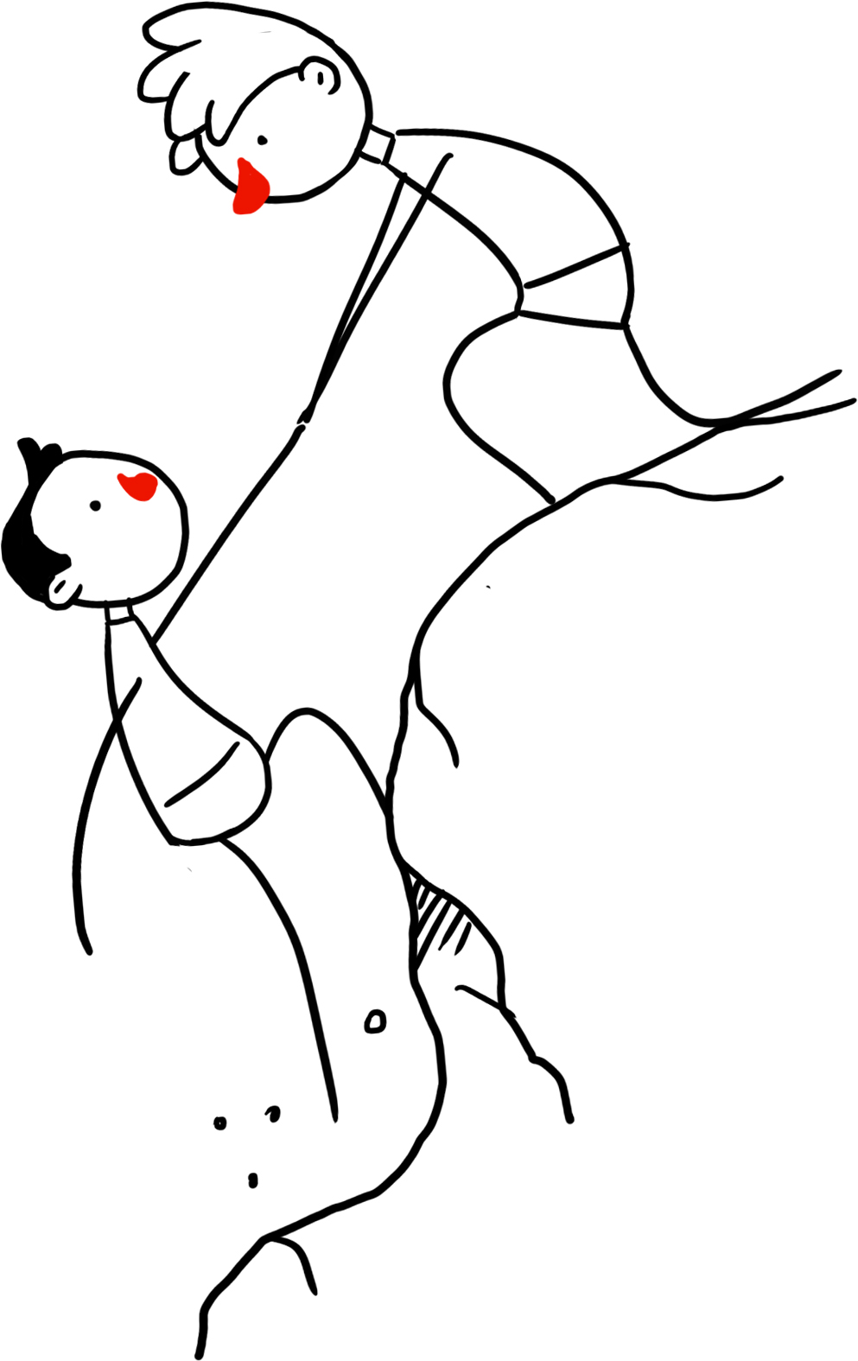

£




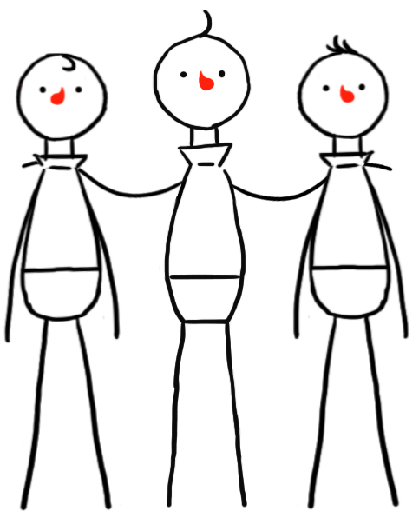


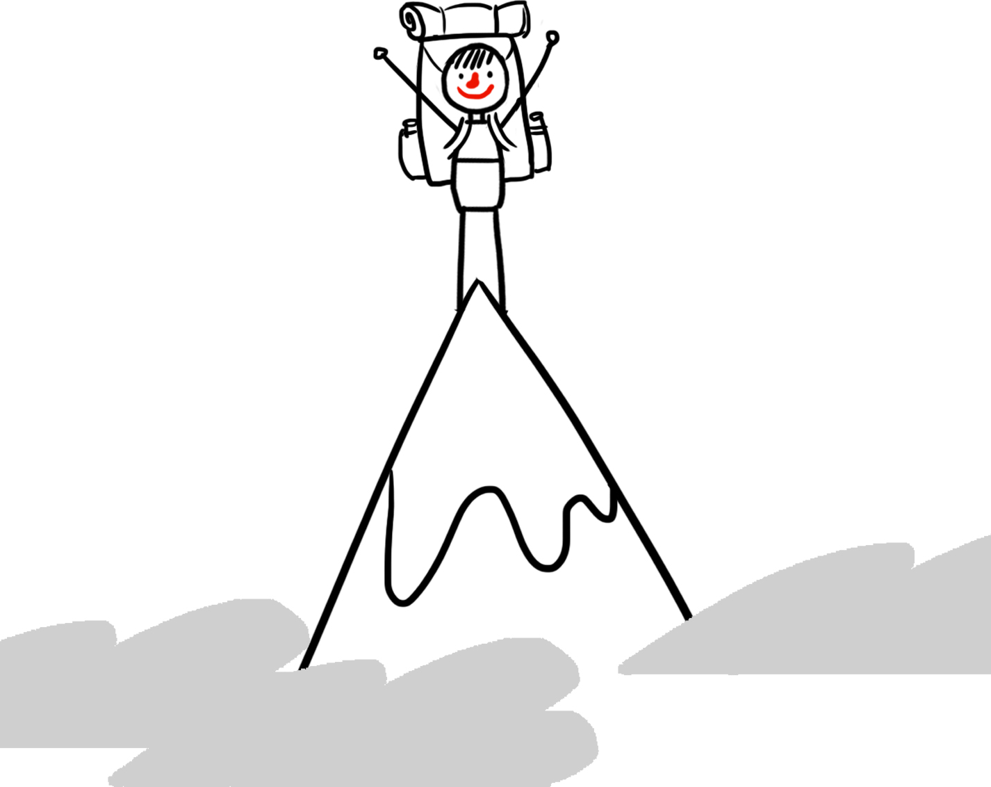

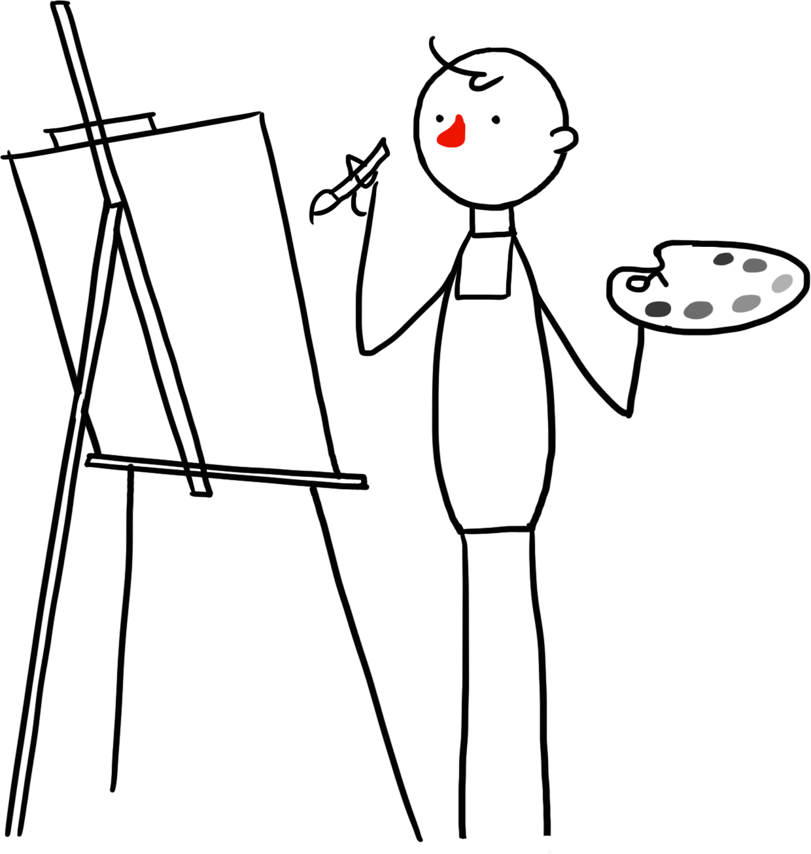









- Which of these ingredients do you think is the most important for happiness?

Tell me more about your choice

- Put a cross through the ingredients that you do not need to be happy.
Tell me more about your choices

- Which three happiness ingredients might be the most important for a Humanist?
Tell me more about your choices
Choice 3
Choice 1
Choice 2

Reason
Reason
Reason

Many Humanists like to think through big questions about life. Taryn is also thinking about happiness.

Think with her through these questions.

Write your thoughts around the thought bubbles.
Is it possible to make everyone happy?
What is the best way to stop people being unhappy?
What sorts of things stop people from being happy?

Is it ok to sometimes not be happy?
I wonder what makes you happy?


Humanists believe that we can all find our own different ways to be happy as long as we don’t harm other people or prevent others from being happy.
Food, drink, and games can be an important part of a happy life.
But more important are making good friends, learning new things, fulfilling our goals, and making others happy.


Read this poem.

‘Happiness is the only good.
The place to be happy is here.
The time to be happy is now.
The way to be happy is to make others so.’

Robert Ingersoll (1833 – 1899)
What does this poem teach you about humanist beliefs about happiness?

Think about everything you have learned in this lesson to help you answer this question: Why is happiness important to Humanists?



How and why do Humanists try to spread happiness?
Humanists do not have holy books or figures of authority to tell them what to do or how to be good. They believe reason and empathy can help them understand how they should behave.

Reason: | thinking about the potential consequences of our actions.
Empathy: | considering how others will feel.

To help us know how to behave, my family tries to follow the Golden Rule.
Treat others as you would like to be treated yourself.

Why do you think it is called the Golden Rule?

If people followed the Golden Rule, how might they be sharing happiness?



‘Treat others as you would like to be treated yourself’ is called the Golden Rule, as this teaching and expectation of behaviour is found in almost all religions, worldviews, and cultures.
I try to do good things because, treating others well makes them happy and making other people happy can make me happy.

I also believe that if everyone tries to do the right thing, we can make the world a better place.

Think through each of these stories and consider about how Taryn would behave if she followed her Humanist beliefs and values.
What would Taryn do and why?
You are playing in a football match and the score is 1:1. In the final minute your teammate crosses the ball to you. You are not confident at heading the ball, but you can reach it with your hand and punch it into the goal. The referee is looking the other way. What should you do?

There is a new boy in your class, who seems really shy and worried. At breaktime you notice they are on their own, but your friends tell you not to go over to him as you already have enough friends.
What should you do?

Your baby sister is crying, and your Mum is trying to cook dinner. You are halfway through a computer game where you are winning. Do you go and sit and play with your baby sister or do you complete the computer game first?

You really want the new album by your favourite band, but you don’t have enough money to buy it. A friend says he knows a website where you can download it for free. He says it’s not the same as stealing. What should you do?

Think about everything you have learned in this lesson to help you answer this question: Why do humanists think they should be good to each other?

I wonder what learning about Humanists has made you think about?


I wonder if you have any other questions about Humanism?

