
Session 2 – Learning question: What do Humanists value?

Read this quote by Richard Norman, a Humanist philosopher.

The satisfaction of creative achievement… the excitement of discovery…relationships with others…the life of the emotions… the enjoyment of beauty in art and nature… These, we know, are the things which enrich our experience.


What does it tell you about what he values as a Humanist?

Taryn and her family are going to share with you what they value.
Read what they say to help you answer the question ‘What do Humanists value?’
Underline the important words in each quote to help you.


I do not believe in an afterlife, so this life is everything to me. We should find what makes us happy and make the most of our lives. We should also try to help others to do the same.



For me, freedom is one of the most important things in life: freedom to live my life however I wish, as long as I do not cause harm to others. All human beings have the freedom to find their own way to make their lives feel meaningful.

The most important thing in life is forming good friendships and relationships with others. The human community is also important, and we should remember that all human beings around the world are part of one extended family. one extended family.

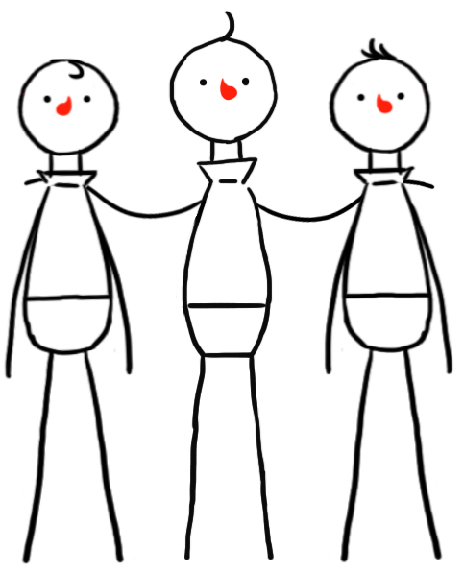


We are all part of humanity and part of the human story. We are all linked across time to our ancestors and our descendants. Human beings have made incredible progress and we should aim to help our children and their children continue that progress. That is the human spirit.

Human beings should celebrate the many intellectual and creative achievements of humankind, such as science, medicine, technology, art, music, and literature. We should try to make the most of our talents and abilities and be optimistic about what we might achieve in the future.

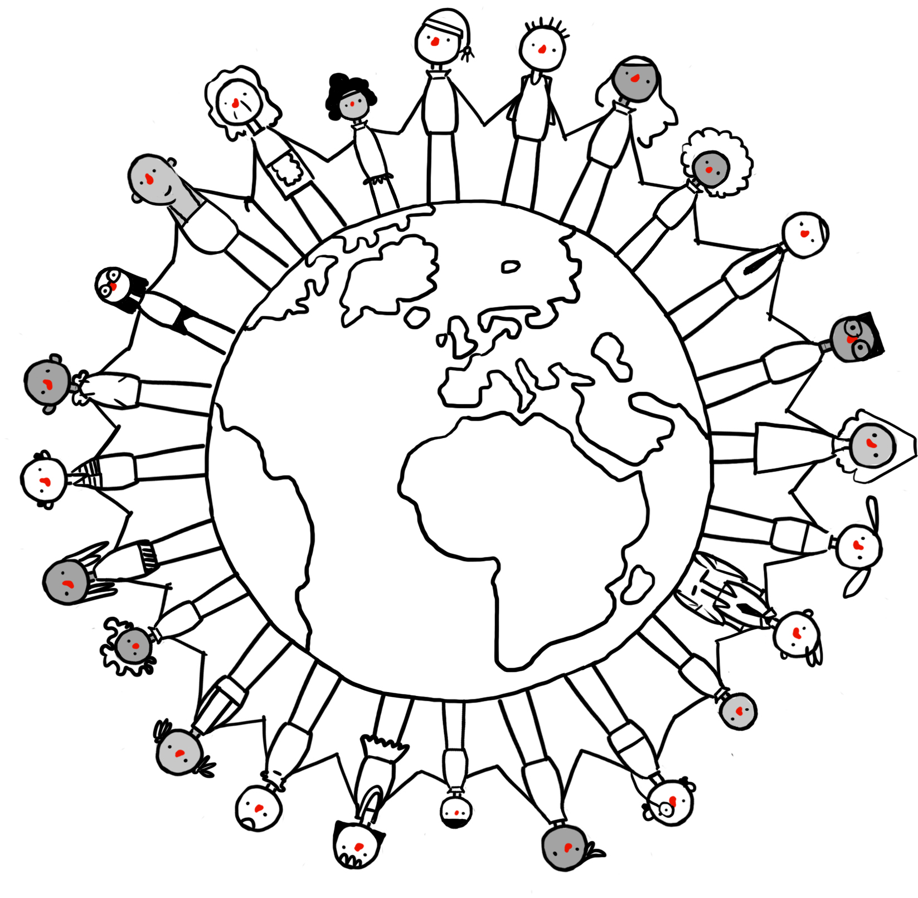

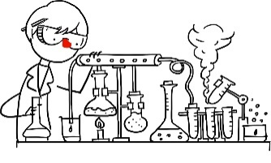

Humanists believe in a world that promotes democracy and human rights. We believe in the importance of equality and social justice. We should work to improve the quality of life for all human beings. Empathy can help me to see how I would like to be treated if I were in somebody else’s situation. We should take care of each other.


I value the natural world around me. Without it we would not survive, and this world is the only one we have. It is a source of beauty and wonder, and we should take care of it.

I value our curiosity and our capacity to ask questions. By looking for evidence, and thinking carefully about the answers, we have been able to discover so much about our world and ourselves and have been able to improve the quality of our lives.




‘What do Humanists value?’
Make a list of all the things that are important to Humanists.



