Session 3 Challenge - Design a humanist building

Humanists have no special places of worship. Many take great pleasure in the wonders of the natural world and believe thinking about nature can also help them to recognise their place in the world.
Many also have great admiration for the many spectacular achievements of human engineering and architecture that can be found all around the world. They stand as symbols of what human beings are capable of.
Many humanists also value libraries, schools, colleges, hospitals, museums, sports facilities, council buildings, and parliamentary buildings as places of public value.
These buildings bring people together to learn, to play, to support each other, or to work for the common good. All of these are activities and goals that many humanists believe we should pursue.

Design a building that represents things that humanists value. Think about all the things you read and learned about Humanist values to help you design this building.
- What might that building be like?
My building will be tall so they can admire the land that they have created
- What would the building be for?
My building will be full of games so that families can come and have a great time playing the games.

Some questions to think about as you plan your building:
- Should a humanist building hug the Earth or reach for the stars?
- Should a humanist building focus more on humanity or the natural world?
- Should a humanist building reflect individual freedom or our connections with other humans?
- Should a humanist building fit with the surroundings or stand in contrast to them? Does it depend on what the surroundings are (e.g. urban or natural)?

Things to consider...
- Location: Where would it be?
- Exterior: What would the outside look like? What is the relationship between the inside and the outside? Should the exterior say something about the purpose of the building? How should the building be accessed?
- Interior: How would the rooms be organised inside and how might they be decorated?
- Other features: What else would there be inside and outside the building? Would there be any words, images, or symbols?
- Activities: What would the building be used for?


Look at these examples of buildings that reflect Humanist values.
What Humanist values can you spot in them?
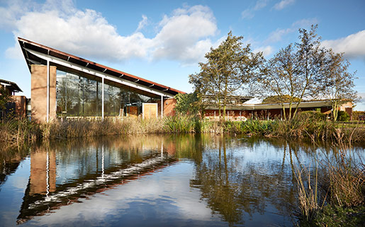
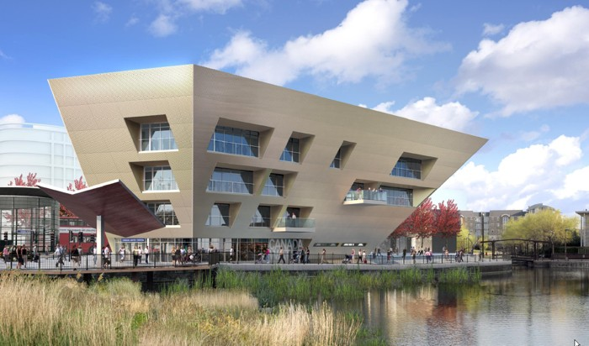

Canada Water Library
Rooted in the ground and nature. Lots of natural light.
Accessible to everyone.
Encouraging aspiration and learning.
Telford Crematorium
The glass wall in the main assembly room allows mourners to gaze out at the surrounding natural landscape, to take comfort from it, and to feel at one with it.

Designs for a humanist retreat
Hannah Flory, Chris Gaunt, and John Cox, University of Liverpool

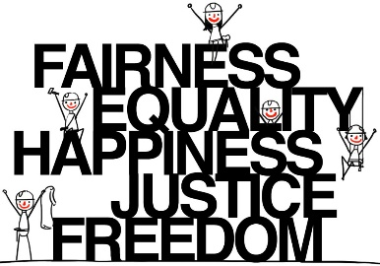
Design a building that reflects Humanist values
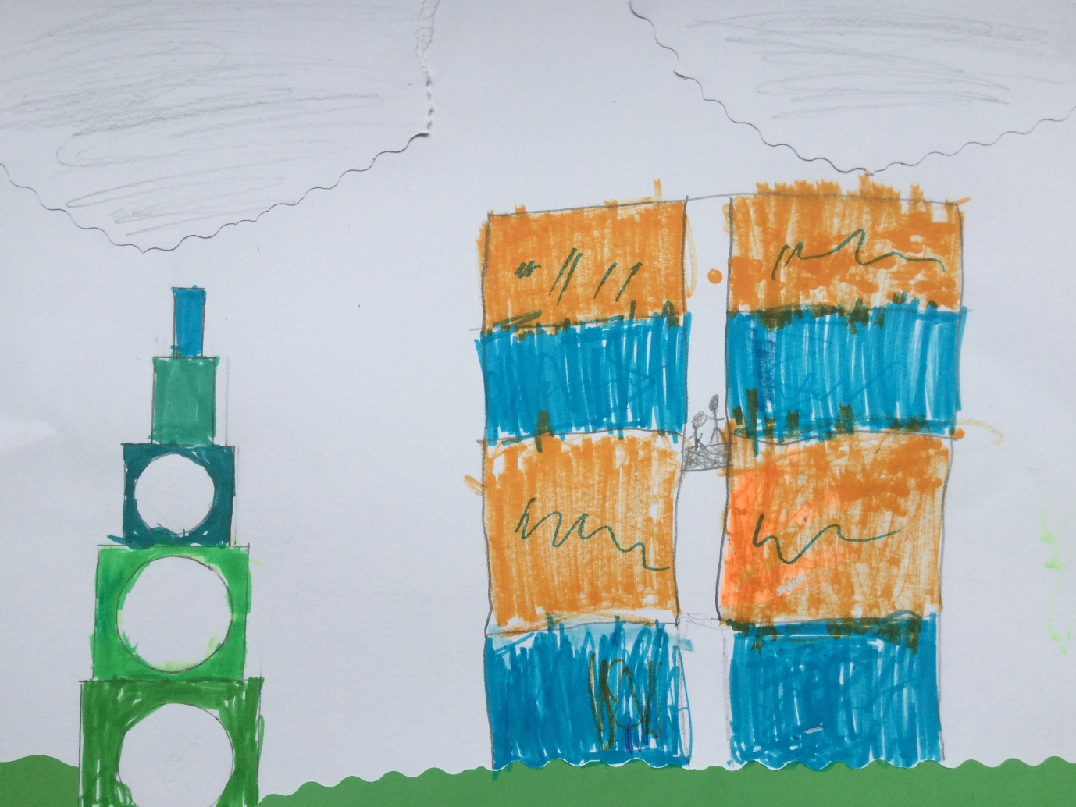


Tell me about your building design.
How does it reflect Humanist values?


My design is a tall structure will a few circular windows. It also has a lift leading up to the top of a house where you can see the stars

.

