JAX AND MERCURY GO TO JUPITER
Jax was small boy with a big dream. Jax loves looking at the stars and is always reading books about space. His dream was to go to Jupiter. One day he asked his dad if it was possible.
“Dad could I go to Jupiter. Is it possible… dad, is it possible? Dad. Is it dad, is it? Could I go? I think I could go… do you think I could go? “
His dad’s got cross when he didn’t know how to do things,
“NO. Don’t be ridiculous Jax. It’s very complicated, you’re too young to understand.”
Jax was undeterred and set to work and within a few weeks, he had built a spectacular rocket-ship. He pinched a couple of spacesuits from the museum ‘Fun Zone’ dressing up box. One for him and one for his dog Mercury. Well, you didn’t really think Jax was going to travel alone, did you? Jax encouraged his reluctant companion into the spaceship and clambered in behind him. It was magnificent. The control stickers were placed with perfect precision and on his first attempt, Jax launched his spaceship into a new world of adventures.
The trip took longer than he had thought, but it was worth it. When they got to Jupiter, they discovered there was already life there! Directly in front of them stood a town with a giant sign floating at the entrance, it said:
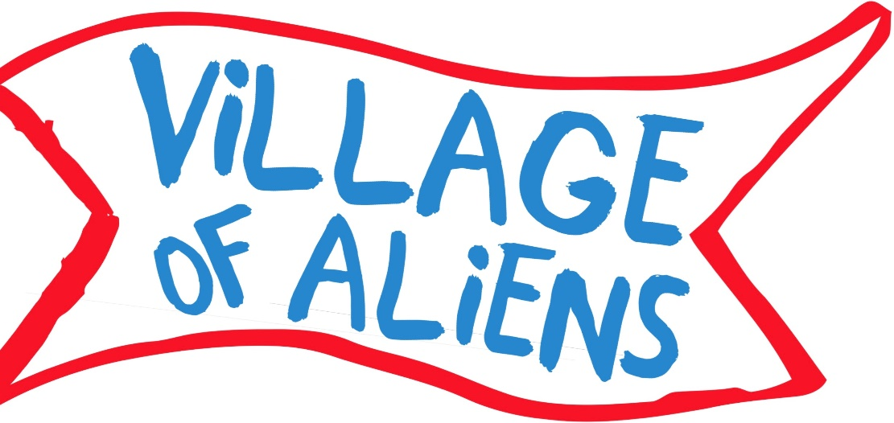
DESIGNED BY CARYS USING GRAPHICS APP

Beyond the sign was a sight to behold: Aliens, real life aliens!
There were green aliens, red aliens, blue aliens, aliens with three eyes, aliens with one eye, aliens with so many eyes it was tricky to count them all! Jax rubbed his eyes (he still had two!) to check he wasn’t dreaming. He struggled to take in everything in. His gaze was broken when Mercury’s bark startled him. Jax whipped around only to see something that looked like this...
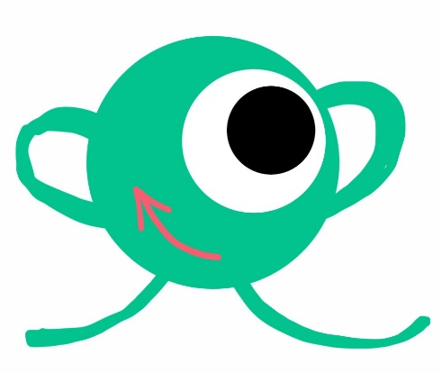
PHILL DESIGNED BY CARYS USING GRAPHICS APP
It was bouncing towards them and gaining momentum.
” RUN” yelled Jax
Jax and Mercury bolted through the village, but the alien was catching up. It was just feet away now. The little alien made a big jump and knocked them all behind the crater. A few seconds later a vast shadow loomed over them.
” Ouch! Who are you?” asked Jax, hoping the little alien can speak English.
”MY NAME IS PHILL” Replied Phill, the alien.
“Why were you chasing me a Mercury, Phill?”
Phill looked confused? ” Mercury?”
“Mercury, my dog.” Said Jax, nodding towards his furry friend.
“I WAS CHASING YOU TO WARN YOU ABOUT THE EVIL OVERLORD”
“Wait, what? Is that big shadow an evil overlord?”
“YES”
“Let’s destroy him!”
“HOLD YOUR HORSES!”
“Why?”
“IT WON’T BE THAT SIMPLE.”
“Says who?” asked Jax cheekily.
“I… WELL, ACTUALLY I DON’T HAVE AN ANSWER FOR THAT.”
Unafraid, Jax stepped out from behind the hut to confront the evil overlord. Jax looked up at the darkness and roared as he charged towards it. Before he got too close to the evil overlord began to disintegrate and in a matter of seconds the evil overlord was gone.
” YAY” screamed the growing crowd that had gathered to see this strange boy and his fluffy friend.
” Huh? How did I do that?”
“I THINK THE SITE OF A HUMAN SOMEHOW DESTROYED HIM, YAY!”
“Cool! Now I have to go home.”
“TAKE ME WITH YOU”
When they got back home Jax got Phill a snack and told him he could not stay. There’s no way his parents would be cool with it.
“You can use the rocket to get back to Jupiter and promise me you’ll come back to visit.”
“I WILL.”
Phill does visit, a lot. He loves KitKats and cheese toasties. Sometimes the trio go on Spaceship adventures, sometimes they just hang out and play Dobble.
BY CARYS

