Friday 15 January 2021
A day out with Grandad
By Henry
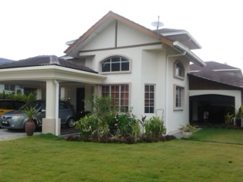
We were playing on the front porch with some toys when grandad asks,
It all starts 9 years ago. I remember it like yesterday. My mum and dad were going to Spain so me and my sister Alice, (three) went to my grandad (Kevin) and grandma (Sheila’s’) house. When we arrived, they were waiting on the front garden (grandad looked huge, with glasses and grey hair). I was so scared. It was my first time alone without my parents. I did not even have my special tiger.
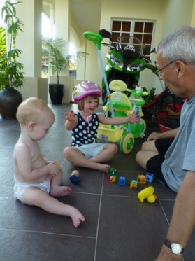
“Shall we go on a walk?”
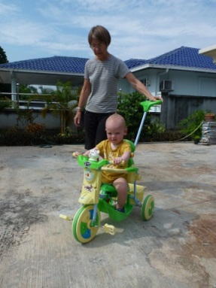
But I was only one, what could I say? I didn’t know where or what we were going to. I hadn’t been out of the gate before.
On the way we saw some bridges. Strangely, I was getting older as we went forwards but when we went backwards, I got younger. I am proud to say we made it to the play park in one piece. I was quite literally shaking.
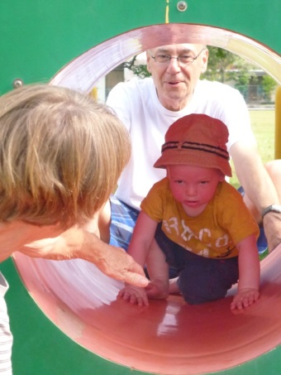
I was exploring a tunnel with grandad and grandma. I almost made it to grandma but then a hole appeared out of nowhere. I fell down the hole headfirst, then slid sideways and spun the right way up. It was just getting faster. Suddenly I stopped. It turned out I ended up in France.

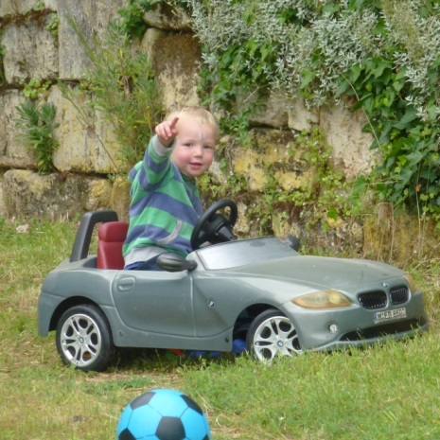
I landed in a small car that looked very familiar. Grandad and Alice were nowhere to be seen. Until No! it can’t be!

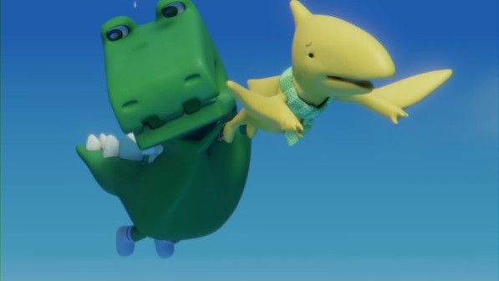
They were flying down towards me. Disguised as dinosaurs so nobody could know that they could fly.

Back together, we adventured through the woods.

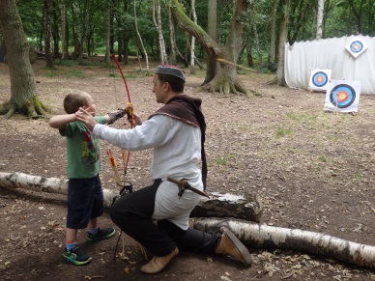
In the woods we saw a man, his name was Robin Hood. He claimed that he was a professional archer. I did not know what to believe! But he was very good. He taught us how to use a bow and arrow. We got the hang of it soon and we were all hitting the target every time. We collected our arrows and picked up our bows and said goodbye to Robin Hood.
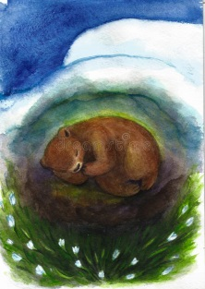
We adventured on and found a cave. Grandad said, “we should stay here and rest.” It feels so good to be able to stop and rest after such a long day. I lay down. It’s surprisingly warm and cosy. I rest my head on something that feels like a pillow but more fluffy. It turned out it was a bear cub who had lost its mum. After our rest we said goodbye to the bear cub and went on.

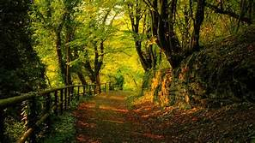
Grandad said, “Some monkeys had escaped from the zoo. They were very vicious towards animals so we should be alright.” I said, “I hope they don’t find the bear cub.”


Up ahead I saw a UFO and something in the window. The little figure in the window ran out of the ship towards us. When he got to us he said,

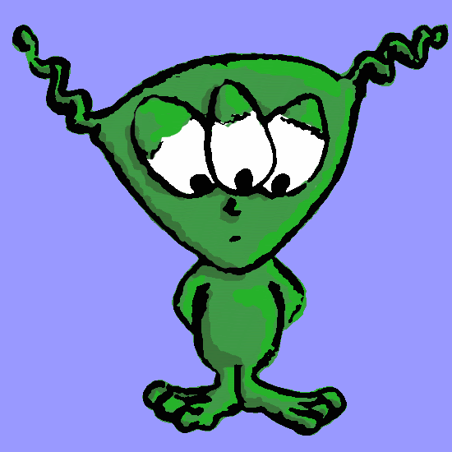
“Come on! Keep running! People will get me!

When we were running, he explained three men were hunting him because he had lots of gold on the ship. They killed my mum and dad and now they are back for me.
I climbed up a tree while grandad and Alice get ready on the ground. I shot a net at their feet and Alice, grandad and the alien jumped on them. They pile on top so the three men cannot run away. The alien whistled. It was an ear-piecing whistle. But billions of aliens came and carried them away and they were never seen again.
The alien showed us a way to get out of the woods quickly.
We saw mum and dad on the way home we got in the car and told them what happened, they hoped it wasn’t true, but we know it is. We got back, packed our bags and said goodbye. On the way back to the airport mum said, “I will never leave you alone with them again!”

