Dear Diary,
12th February 2019
Today I arrived in Bangkok It was so hot I thought I was in a sauna. It was busy, it didn`t help that I had no idea what the time was due to jetlag. We went to a restraunt with Cherdchai, mum’s Thai friend. The restraunt`s roof looked like it was almost certainly going to fall down on us. The dumplings were gross, so called, food!
13th February 2019
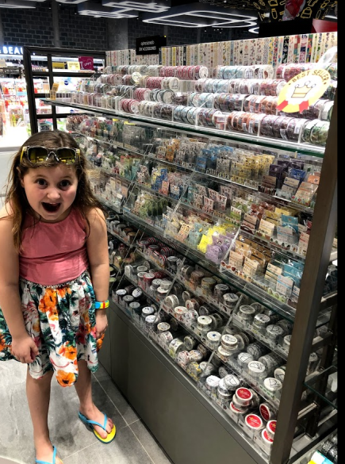
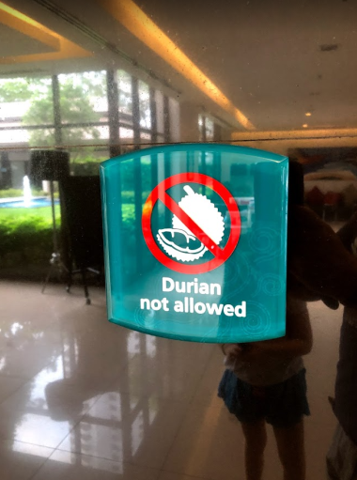
So, this morning was my first proper day in Thailand! The breakfast was not ordinary breakfast... no English breakfast, just all kinds of fruit and egg. I was very hungry as last night`s food was not a lot. I had mango and other fruit. Mum had to work at the hotel business place, so me and Dad decided to go to the pool to recover from our jetlag. We went to our room noticing the sign saying ‘NO DURIAN ALOWED’ (fruit that smells like rotten corpse). The pool was awesome. Then we had lunch at the hotel Dad said he was worried that I wouldn`t like the food... I put more chilli on it before he could stop me. It was delicious. In the afternoon we went for a walk to keep ourselves awake and went to the biggest shopping mall in Thailand (which was considered a tourist destination). It had lovely air conditioning and an indoor floating market. I had to buy new flip flops and found Asia had washi tape shops! I may have convinced dad to buy me a few
14th February 2019
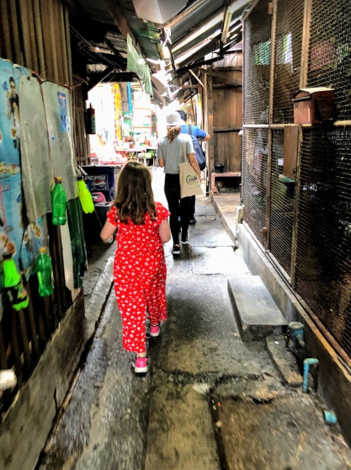
Valentine’s Day in Thailand. Me and Dad went sightseeing in Bangkok with my mum’s Thai students Ni and Dear. We saw Wat Pho (beautiful temple) via river ferry and it was so hot and sweaty. We needed to cool down and went for a life saving ice cream. Ni and Dear took us through a strange and scary alley way leading to a beautiful, and air conditioned, restaurant. Bliss.
After lunch we saw the Reclining Buddha. We had to take off our shoes (out of respect to Buddha) and see this huge, never ending, GOLD, statue of Buddha.
Went on my first Tuk Tuk. They are mad.
16th February 2019
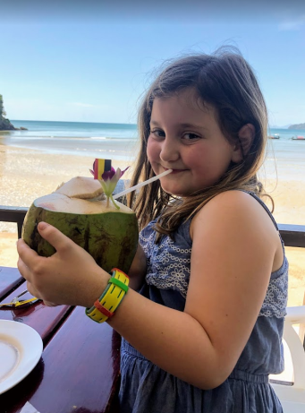
Mum finished work yesterday and we are now starting our beach break. We have flown south from Bangkok to Ao Nang in the Krabi province of Thailand. Drank a coconut, didn’t like it .
Chilled and explored the local area (including the pool)! Getting used to the heat and humidity now.
Went for a walk in the evening to have dinner and ate at a sala. It was really odd... it had cushions instead of seats, STRANGE?
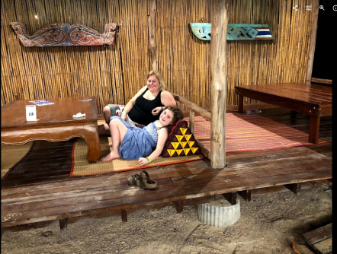

17th February 2019
Today we got up slightly earlier because of a snorkelling tour in a boat! We went basically strait there after breakfast. It was awesome; we went snorkelling in a coral reef and saw a island from the boat that we weren’t allowed to go on because of all the monkeys. After lunch our boat stopped in the middle of the sea, so that we could jump off into a coral reef and go snorkelling. When I jumped off the boat I felt like I was swimming though the most beautiful sight I had ever seen. There were hundreds of beautiful, colourful parrot fish, clown fish and long thin pipe fish. The coral below seemed like something out of a film, it was florescent colours of the rainbow, they looked like flowers under the water.
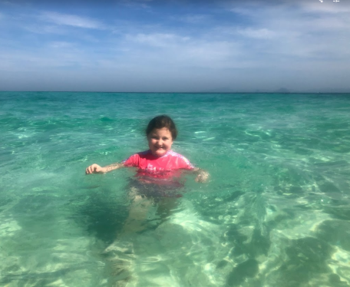
18th February 2019
Railay beach, Krabi. This evening at sunset we went down to the beach to meet with a group to go paddle boarding. The Boards and kayak had lights at the bottom so that you could see the fluorescent coral and fish below. It felt peaceful as the last of the sun reflected on the teal waves. The coral looked like it was shinning pinks and oranges below in the light of the board. Once it was properly dark we stopped at the mouth of a cave in the sea. We turned off all the lights and splashed our hand in the water to see fluorescent plankton glowing. The plankton looked like little diamonds in the sea. I was able to jump in the water and swim in the sparkling sea in the moonlight with the glowing plankton. It was a once in a lifetime opportunity and a magical memory that I will always remember.


