Greece (Kos)
Dear Diary,
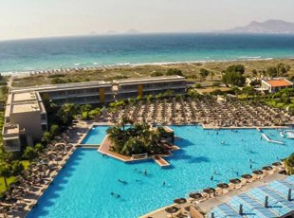
Last year in August, me and my family went to kos in Greece. Before my mum and dad booked the holiday, there was a slight issue with our other holiday we were supposed to go to but because of COVID-19 we were not allowed to travel to Lanzarote. Luckily, my mum and dad managed to book us the holiday in Greece. Before I got on the plane, I was still worried about if the pilots would take off or not, but in the end, it flew off. When we got there, it was dark but really warm. The resort was called blue lagoon resort. Once we got checked in a man drove us to the resort but as our nanna and grandad came with us, they had to stay in a different part of the resort. Me and my sister were so tired after the long journey. We couldn’t wait to go to sleep.

In the morning, me and my sister were so excited and pumped to start the fun. But before that we went to get breakfast. We thought it would just be a normal, regular breakfast but then we realised that it was a buffet and that we could eat whatever we wanted! There were scrambled eggs, toast, sausages, beans, querants, fruit, bacon and pancakes. It looked so yummy so we quickly got a table and went to get our food. After that we were stuffed so we went for a walk to find our nanna and grandad’s room. Once we found them, we all went to the pool.
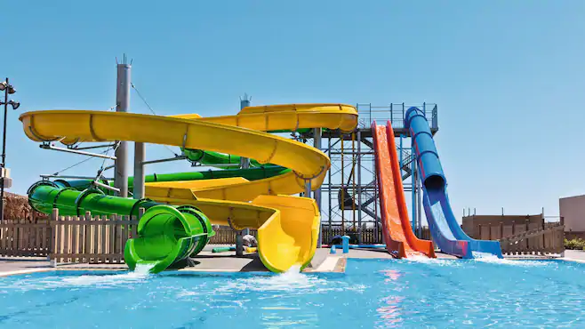
Every day we went to the pool, the water park with the steep slides and the beech. Every night a group of people would do a show. My favourite one was the Disney theme.

When it was time to go, we jumped back on the bus and went to the airport. After the flight, I felt really sick. We were just about to leave because we got our bags until are nanna noticed one of her suitcases was missing! We checked everywhere until a man told as it accidently went on a different plane. She was furious but they said they will post it. On the drive back from the airport I still felt really sick and that’s when I threw up!

