Ernest Shackleton
Sir Ernest Henry Shackleton was born in February the 15th 1922. He died in 1922 aged 47. Shackleton was a polar explorer, he led three British expeditions to the Antarctic. Shackleton first went to the Antarctic on Captain Robert Scott's 1901-1904 expedition but he was sent home as he was ill. In 1907, he went back to the Antarctic and in January 1909 was part of a group who walked further south than anyone had ever been before, travelling to within 190 kilometres of the South Pole. He wanted to walk across Antarctica from one side to the other crossing the South Pole in the middle. But then disaster struck on the ship. People were trapped in ice. They spent 281 days on board waiting for the ice to break again, but the boat was slowly crushed to pieces. Shackleton and his men dragged their lifeboats over many miles of snow and ice to reach sea. They set sail in the lifeboats and eventually reached an Island. In April 1916, Shackleton and four others sailed hundreds of miles to South Georgia to get help at the whaling station there. This was a journey of 1,300 kilometres (810 mi) and took 16 days. Unfortunately, the boat he was in landed on the wrong side of the island and they had to climb over the mountainous middle section to reach the whaling station. A rescue party saved everyone from Elephant Island in August 1916.

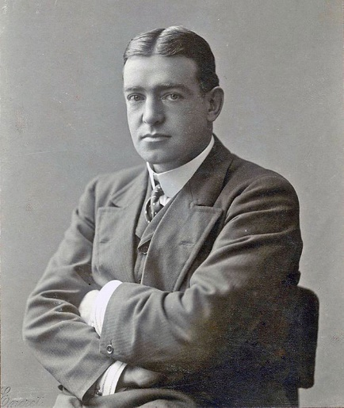
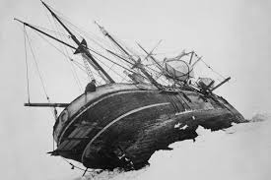
In 1921, Shackleton returned to the Antarctic, intending to carry out a programme of scientific activities. Before the expedition could begin this work, Shackleton died of a heart attack on 5 January 1922 while his ship, Quest, was moored in South Georgia. At his wife's request, he was buried there.

Senteceses:
I complained about the disater that happened to my ship.
I was keen to get my work done.
My great grandfather has been on many expeditions to the antartica.
I was restless to find out my rusults from my covid test.
A explorer find a rare jewel down in a acient tomb, it was very mysterious.
There are seven continents in the world.
There was a vast amount of money behind my bed.
I had an epic football match because I got a hatrick.
My dad was a heroic hero because he saved me from a shark attacking me.
I was fraught with danger on the way to america because the plane almost crashed.
I periled to jump in a festive pool of great white sharks.
I had endurance to keep going in the race.

