Hubert Hudson

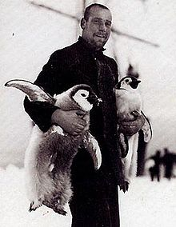
Born 17th September 1886 in London. Died 15th June 1942 during World War 2.
Huberht Hudson was from a big family he had 6 siblings. He was the second oldest of the children.
He was known as a dull character, his nickname was buddha. This was because he was tricked to dress up as a buddha for a fancy dress party. He wore a robe and a teapot lid on his head. When he got there he was the only person who dressed up as it wasnt really a fancy dress party.
He joined the merchant service in 1901 then commissioned to the royal nature reserve in 1913. When he joined shakletons expedition to Antarctica.
He was known especially for catching penguins. Which they had to eat to keep themselves alive when they was stuck on the ice.
After the expedition he served in world war 1 working on mystery ships. He later served in world war 2 which is when he died by a torpedo hitting the vessel he was on.

