Leonard Hussey OBE
Leonard Duncan Albert Hussey Born 6/6/1891.
Lived in Leytonstone, London. With his parents and one of nine children.
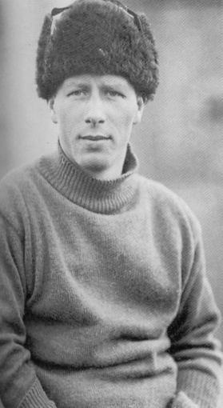

1909 he enrolled at the university of London in Kings College.
He Left with a degree in Psychology, Meteorology and Anthropology.
Psychology means the scientific study of the human mind and it function.
Meteorology means A weather forecaster.
Anthropology means the study of human behaviour and biology.
1914-1917 Leonard Hussey became a crew member of the Shackleton trans Antarctica expedition. He became an invaluable addition to the crew helping to raise their spirts and moral. He entertained with his banjo playing.
Hussy was also a member of the armed force in ww1 where he served in France and in Russia with Shackleton.
After WW1 Leonard Hussey career had turned toward medicine and in 1923, he was a member of the Royal Collage of Practice where he stayed in London until 1941.
He then served again in ww2 as a medic in the royal Navy.
1946 after the war Leonard Hussy was awarded the OBE for his work as a medical officer.
OBE (Order of the British Empire).
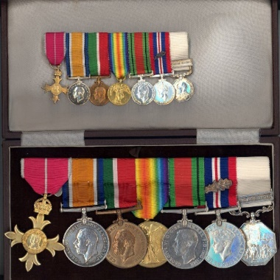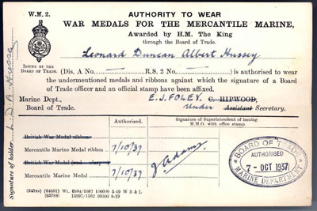
1949 Leonard Hussey published his own book called South with endurance.
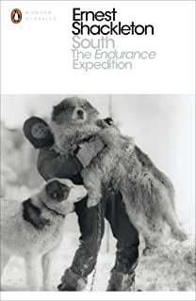
Same year he served as a ship’s surgeon on the SS Clan Macauley which sailed from England to South Africa then Australia.
He contained to be a GP until 1957 the same year he become president of the Antarctic club.
1959 Leonards Hussey famous banjo was donated to the British Museum.
Leonard was married but had no children and in 1964 he died ages 72.
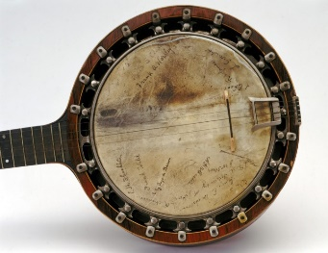

By Taylor

