Dr James McIlroy
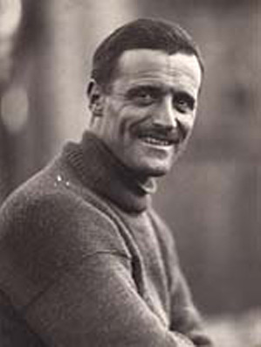

Early life and previous experience

James McIlroy was born in the Irish province of Ulster on 3rd of November 1879. The family later moved to Kings Norton, Birmingham, England, where he attended grammar school. His first job was an office job but he soon realised that desk work was not for him. He decided to study for the medical profession. After McIlroy earned his medical degree at Birmingham University, he was for a brief time a surgeon at Queen Elizabeth Hospital in Birmingham. He spent several of the following years practicing medicine in Egypt, in Japan, and as a ship's surgeon, on cruise ships around the East Indie.

Antarctic expedition 1 (Endurance)

in 1914 James McIlroy heard of Shackleton’s intended expedition to the Antarctic. He was interviewed and got the job as a second surgeon alongside Alexander Macklin. During the expedition McIlroy was put in charge of the sled dog team and was seen by his fellow crew members as a “man of the world” because he told stories of all his trips around the world. During the first expedition in 1914 McIlroy was the surgeon who amputated Perce Blackborow’s toes because they went gangrene from frostbite. During the expedition the crew were lost for nearly 6 months and eventually they were able to sail to Elephant Island in 3 small boats.

Military service

After the first expedition McIlroy served in world war 1. During the war he was badly injured and when the war ended he became chief surgeon for the P&O line.

Antarctic expedition 2 (Quest)

In 1922 McIlroy was asked by Shackleton to join his second expedition called Quest.

After the Quest expedition, McIlroy returned to work at sea on the P&O lines.

Later Years

When McIlroy retired from the P&O Line he moved to Wales but soon found that he preferred to live at sea rather than on land. He returned to sea to work on the Clan Line but gave a false date of birth to get the job. He continued to work on ships until his late 70’s. He finally retired for good and lived in Surrey. He later did there in 1968 at the age of 88.

Honours and Memorials

In 1990 the UK Antarctic Place Names Committee named a peak at the Antarctic after James McIlroy. It was named McIlroy Peak.

Map of the Antarctic Expeditions



