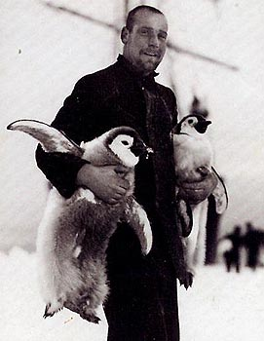 |  | Huberht taylor hudson  Chief Navigation Officer
Profile  As a Second Navigational Officer I am responsible for performing vessel navigation of the ship. I am a highly motivated responsible person who has excellent leadership and communications skills, I can lead as well as follow orders. As the sole navigation officer, I need to learn quickly and be able to solve problems and communicate the resolve to the appropriate people keeping the safety of everyone aboard at the forefront of my mind.  Contact  PHONE:  0800001066  Email:penguincatcher@iceberg.com |  | EDUCATION  West Minster School For Boys  September 1890 – September 1898  London Nautical School For Boys  September 1898 – September 1902  WORK EXPERIENCE  Royal Navy Deck Cadet  September 1902–October 1907  As a Deck Cadet I assisted in the day to day operations and maintenance of the ship. I helped with preparations prior to departure also navigation, safety and maintenance duties whilst at sea.  Royal Navy Third Navigation Officer  October 1907–June 1911  As the Third Navigation Officer I was forth in command and was a fully licensed member on deck of a naval ship. I reported directly to the officer of the watch I also acted as a co-navigator and during the day the role of officer of the watch.  Royal Navy Second Navigation Officer  June 1911–January 1917  As the Second Navigation Officer I acted as an understudy to the First Officer. I was solely responsible for the navigation of the ship and keeping charts and publications up to date. Other duties included monitoring the navigation and radio equipment. Also undertaking bridge watches when at sea.  Skills

Leadership Skills
Communications Expert
Creative Thinking
Ability to learn quickly
Creative problem solving
Work to deadlines
Work within a team

