
Come to our exciting new fundraising
event and help raise money so that
we can keep caring for our local people.
Saturday 03 April 2021. 1pm – 3pm at West Malling CEP School, Old Cricket Ground, Norman Road, West Malling, Kent, 6RL.

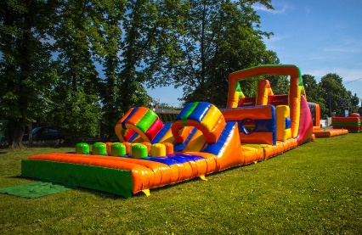


Bring your friends and family and join in on the fun. There will be an Inflatable obstacle course, Raffle tickets with great prizes, food and drink stalls, face painting & much more

