Triple challenge week
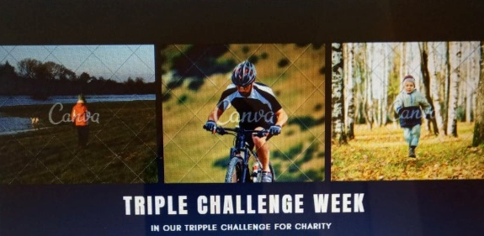
From the first to seventh October, we are doing a triple challenge week.
We want you to join in, to help the hart of Kent hospice and have fun.
You will take part in a run, walk and cycle at Manor Park in West Malling. There will be cakes and drinks at the start and finish also merchandise like t-shirts and bags for you to bye. The day starts at 9am-4pm. Sign up now at Manor Park.
Adults = £10
Kids =£5
Under three years =free

After the challenge go to the tent and collect your prize.
Sign up now at Manor Park
The signup sheets will be next to the ticket machine in the car park.

Connections to the hospice

Phoebes connections -
My grandad had terminal cancer. The hospice made his last week’s more pleasurable than in a hospital and supported him and my family though the tough times.

Henrys connections –
My mum worked at the hospice for a few years and the people that work there are brilliant. They are kind, caring and willing to help anyone in need.

